# 罗氏流水线IT3000

## 接口说明

| 仪器厂商 | 罗氏流水线 | 仪器型号 | IT3000 |
| --- | --- | --- | --- |
| 通讯方式 | 主动上传 | 仪器类型 | 生化发光流水线 |
| 医院名称 | 厦门翔安医院 | 程序名称 | MI.MIFIT3000 |
| 终端服务器地址 |  | 终端服务器端口号 |  |

## **仪器上接口标示和接口类型**

1. 接口类型：监听文件

1. 连接方式：抓取RESULT结果文件和SEEN处理文件 .hl7文件，上传ORDERS .hl7文件

## 仪器接口说明

* 罗氏流水线与lis交互分为处理文件 SEEN 和结果文件 RESULT 两种以及血清图片，处理文件过多，lis读取文件和解析文件同时进行，造成结果文件无法及时解析，造成仪器传了结果但是未及时读取造成无法及时发报告。针对这一问题，详细在问题处理中无法及时读取文件处理造成获取结果过慢记录。

* 接口中包含多种功能，包含血清图片，自动核收，报警信息存储等。详细在仪器个性功能中展示。

## **数据格式**

## 修改记录

| 序号 | 日期 | 操作人 | 说明 |
| --- | --- | --- | --- |
| 1 | 2025-04-03 10:15:50 | 杨浩然 |  |

## 仪器接口程序

/// [{"MachID":"#RowID","Type":"Drect","UpTime":"3000","Address":"Z:\\ResultExport\\","UpCDF":"","UpREF":"","DealProcess":"MI.MIFLICA800","Para":".csv","PreDealClass":"PreDeal.DealDemoM,PreDeal","UPPreDealClass":"PreDeal.DealDemoM,PreDeal","UpPara":"Z:\\Imports\\"}]  
Class MI.MIFIT3000N1 Extends %RegisteredObject  
{  
  
/// D ##class(MI.MIFInfinity).fileMTHD("7","MSH|^~\&|PACMAN|PACMAN-LAB|PSM|PSM-LAB|20181122074821||ORU^R01|93113761|Q|2.4||||NE||8859/1|#enter#PID|1|#enter#ORC|1|T1|||IP|#enter#OBR|1|||||||||||||||||||503|#enter#OBX|||TNT-HS^3256^||0.145^|g/L|^^||||F|||20181122074817|503^COBASE602:#2#1|#enter#NTE|1|I|Code:0 Comment:No Alarm|#enter#","")  
/// seen: [VT]#enter#MSH|^~\&|LIS||HOST||20220908183340||ACK^^ACK|b6a6bb63-774a-46a5-adf3-0d409dd058ad|P|2.5|||ER|ER||8859/1[CR]#enter#EQU||^^^MILESTONE1^^SAMPLEEVENT^SEEN|20220908183340|[CR]#enter#SAC|||1000100990|1000100990||20220908183340|01||P|MILESTON1|0@0[CR]#enter#[FS][CR]  
/// result: [VT]#enter#MSH|^~\&|HL7SND|FAC1|HL7REC|FAC2|20210922075000975_1000100990||RESULTS□|20210922075000975_1000100990|P|2.3|||ER|ER||8859/1[CR]#enter#PID|1||1000100990|1000100990|^Test||19811002|F[CR]#enter#PV1|||041||||||||||||||||^^^^^^^^产六科|[CR]#enter#DG1|||宫内孕37+5天[CR]#enter#ORC|NW|1000100990|1000100990||||RI||20210922075000|医保|10001|041|||||||[CR]#enter#OBR||1000100990||GLU|||||||A[CR]#enter#OBX|1|NM|GLU||1.1||||||F|||20210922101033|c6000^E11[CR]#enter#[FS]□[CR]  
/// D ##class(MI.MIFRS600).fileMTHD("56","","")  
/// seen: D ##class(MI.MIFRS600).fileMTHD("56","[VT]#enter#MSH|^~\&|LIS||HOST||20220908183340||ACK^^ACK|b6a6bb63-774a-46a5-adf3-0d409dd058ad|P|2.5|||ER|ER||8859/1[CR]#enter#EQU||^^^MILESTONE1^^SAMPLEEVENT^SEEN|20220908183340|[CR]#enter#SAC|||1000100990|1000100990||20220908183340|01||P|MILESTON1|0@0[CR]#enter#[FS][CR]","")  
/// result:D ##class(MI.MIFRS600).fileMTHD("56","[VT]#enter#MSH|^~\&|HL7SND|FAC1|HL7REC|FAC2|20210922075000975_1000100990||RESULTS□|20210922075000975_1000100990|P|2.3|||ER|ER||8859/1[CR]#enter#PID|1||1000100990|1000100990|^Test||19811002|F[CR]#enter#PV1|||041||||||||||||||||^^^^^^^^产六科|[CR]#enter#DG1|||宫内孕37+5天[CR]#enter#ORC|NW|1000100990|1000100990||||RI||20210922075000|医保|10001|041|||||||[CR]#enter#OBR||1000100990||GLU|||||||A[CR]#enter#OBX|1|NM|GLU||1.1||||||F|||20210922101033|c6000^E11[CR]#enter#[FS]□[CR]","")  
/// [{"MachID":"#RowID","Type":"Drect","UpTime":"3000","Address":"E:\\Temp\\Temp\\Interface\\Results,E:\\Temp\\Temp\\Interface\\Seens","UpCDF":"","UpREF":"","DealProcess":"MI.MIFXAIT3000","Para":".hl7","PreDealClass":"PreDeal.DealDemoMAll,PreDeal","UPPreDealClass":"PreDeal.DealImage,PreDeal","UpPara":"E:\\Temp\\Temp\\Interface\\ORDERS\\"}]  
/// [{"MachID":"#RowID","Type":"Drect","UpTime":"3000","Address":"E:\\Temp\\Temp\\Interface\\Results,E:\\Temp\\Temp\\Interface\\Seens","UpCDF":"","UpREF":"","DealProcess":"MI.MIFXAIT3000","Para":".hl7","PreDealClass":"PreDeal.DealDemoMAll,PreDeal","UPPreDealClass":"PreDeal.DealDemoM,PreDeal","UpPara":"E:\\Temp\\Temp\\Interface\\ORDERS\\"}]  
/// D ##class(MI.MIFIT300N).fileMTHD("34","MSH|^~\&|LIS||HOST||20250317162926||ORU^R01^ORU_R01|20250317162926573175|P|2.5|||AL|ER[13][10]PID|1||0000486028||^郑龙怡||20000126|F[13][10]PV1|1|U|||||||||||||||||^^^RI^^^^^感染性疾病科[13][10]ORC|SC|1003777033|||CM||||20250317160618[13][10]OBR|1|1003777033|||||||||||||||||||||||F[13][10]OBX|1|NM|TRAB^TRAB||<0.800|||LIMTL|||F|||20250317170643|E1^MU1-e801-1-2@5503[13][10]NTE|1||LIMTL[13][10]NTE|1||LIMTL[13][10]")  
/// D ##class(MI.MIFIT3000N1).fileMTHD("34","MSH|^~\&|LIS||HOST||20250320102229||ORU^R01^ORU_R01|20250320102229442999|P|2.5|||AL|ER[13][10]PID|1||0000481255||^杨建利||19880623|M[13][10]PV1|1|U||||||||109|||||||||^^^RC^^^^^健康管理中心[13][10]ORC|SC|1003782597|||CM||||20250320084145||||||||109[13][10]OBR|1|1003782597|||||||||||||||||||||||F[13][10]OBX|1|NM|GLU^GLU||8.830||||||F|||20250320100301|C2^MU1-c702-2-2@5607[13][10]OBX|2|NM|UREA^UREA||4.330||||||F|||20250320100306|C2^MU1-c702-2-1@5607[13][10]OBX|3|NM|UA^UA||434.900||||||F|||20250320100254|C2^MU1-c702-2-2@5607[13][10]OBX|4|NM|TP^TP||79.900||||||F|||20250320095858|C1^MU1-c702-1-1@5607[13][10]OBX|5|NM|ALB^ALB||46.000||||||F|||20250320095348|C1^MU1-c702-1-2@5607[13][10]OBX|6|NM|TBIL^TBIL||6.000||||||F|||20250320095923|C1^MU1-c702-1-1@5607[13][10]OBX|7|NM|DBIL^DBIL||1.800||||||F|||20250320095901|C1^MU1-c702-1-1@5607[13][10]OBX|8|NM|ALT^ALT||107.000||||||F|||20250320095900|C1^MU1-c702-1-2@5607[13][10]OBX|9|NM|AST^AST||62.300||||||F|||20250320095909|C1^MU1-c702-1-1@5607[13][10]OBX|10|NM|RGT^RGT||68.800||||||F|||20250320100259|C2^MU1-c702-2-1@5607[13][10]OBX|11|NM|ALP^ALP||83.700||||||F|||20250320095907|C1^MU1-c702-1-2@5607[13][10]OBX|12|NM|TRIGL^TRIGL||8.810||||||F|||20250320100304|C2^MU1-c702-2-2@5607[13][10]OBX|13|NM|TC^TC||4.910||||||F|||20250320100257|C2^MU1-c702-2-2@5607[13][10]OBX|14|NM|SCRE^SCRE||66.400||||||F|||20250320100313|C2^MU1-c702-2-1@5607[13][10]OBX|15|NM|9CYSC^CYSC_NEW||0.89||||||F|||20250320095916|C1^MU1-c702-1-1@5607[13][10]OBX|16|NM|9HDL^HDL_NEW||0.69||||||F|||20250320095914|C1^MU1-c702-1-2@5607[13][10]OBX|17|NM|9LDL^LDL_NEW||2.06||||||F|||20250320095921|C1^MU1-c702-1-2@5607[13][10]OBX|18|ST|XYZL^DM_SERQ||Z:脂血||||||F|||20250320083356[13][10]")  
/// D ##class(MI.MIFIT3000N1).fileMTHD("34","MSH|^~\&|LIS||HOST||20250320151725||ORU^R01^ORU_R01|20250320151725880554|P|2.5|||AL|ER[13][10]PID|1||0000095425||^姚程成||19980712|M[13][10]PV1|1|U|||||||||||||||||^^^RC^^^^^健康管理中心[13][10]ORC|SC|1003784045|||CM||||20250320104114[13][10]OBR|1|1003784045|||||||||||||||||||||||F[13][10]OBX|1|NM|TP^TP||73.600||||||F|||20250320115059|C1^MU1-c702-1-1@5095[13][10]OBX|2|NM|ALB^ALB||49.600||||||F|||20250320114553|C1^MU1-c702-1-2@5095[13][10]OBX|3|NM|TBIL^TBIL||16.400||||||F|||20250320115110|C1^MU1-c702-1-1@5095[13][10]OBX|4|NM|DBIL^DBIL||4.400||||||F|||20250320115056|C1^MU1-c702-1-1@5095[13][10]OBX|5|NM|ALT^ALT||18.100||||||F|||20250320115057|C1^MU1-c702-1-2@5095[13][10]OBX|6|NM|AST^AST||22.900||||||F|||20250320115103|C1^MU1-c702-1-1@5095[13][10]OBX|7|NM|RGT^RGT||8.900||||||F|||20250320115522|C2^MU1-c702-2-1@5095[13][10]OBX|8|NM|ALP^ALP||78.100||||||F|||20250320115105|C1^MU1-c702-1-2@5095[13][10]")  
/// D ##class(MI.MIFIT3000N1).fileMTHD("34","MSH|^~\&|LIS||HOST||20250321083434||ACK^^ACK|20250321083434378641|P|2.5|||NE|NE[13][10]EQU||^^^c702^^SAMPLEEVENT^SEEN|20250321083434[13][10]SAC|||1003775669|1003775669||20250321083433|01||P|c702|5719@4[13][10]")  
/// D ##class(MI.MIFIT3000N1).fileMTHD("34","MSH|^~\&|LIS||HOST||20250328191032||ORU^R01^ORU_R01|20250328191032737830|P|2.5|||AL|ER[13][10]PID|1||0000531818||^郑苹||19811117|F[13][10]PV1|1|U|||||||||||||||||^^^RI^^^^^心血管内科[13][10]ORC|SC|1003802907|||CM||||20250328191358[13][10]OBR|1|1003802907|||||||||||||||||||||||F[13][10]OBX|1|NM|U-CR^U-CR||5924.00||||||F|||20250328200846|C2^MU1-c702-2-1@4003|||||||||5924.00[13][10]OBX|2|NM|UR-MALB^UR-MALB||15.30|||OBS.RR|||F|||20250328200852|C2^MU1-c702-2-2@4003|||||||||15.30[13][10]NTE|1||OBS.RR[13][10]")  
/// 非流水线分区代码  
Parameter FQCode = "WANTAI,XINCHANYE,LINJIAN,XIEGUANG";  
  
ClassMethod fileMTHD(mi, record, epis, filename, P4, P5, P6, P7, P8, P9, P10, P11, P12, P13, Sessions, Output RowCount As %String) As %String  
{  
 s mi=$g(mi),record=$g(record),epis=$g(epis),filename=$g(filename),P4=$g(P4),P5=$g(P5),P6=$g(P6),P7=$g(P7),P8=$g(P8),P9=$g(P9),P10=$g(P10),P11=$g(P11),P12=$g(P12),P13=$g(P13),Sessions=$g(Sessions)  
 i filename["Results" j ..ResultDo(mi, record, epis, filename, P4, P5, P6, P7, P8, P9, P10, P11, P12, P13, Sessions) q ""  
 e d ..ResultDo(mi, record, epis, filename, P4, P5, P6, P7, P8, P9, P10, P11, P12, P13, Sessions) q ""  
}  
  
ClassMethod ResultDo(mi, record, epis, filename, P4, P5, P6, P7, P8, P9, P10, P11, P12, P13, Sessions, Output RowCount As %String) As %String  
{  
 s mi=$g(mi)  
 s epis=$g(epis)  
 i '$d(^dbo.BTMIMachineParameterD(mi)) q "0"  
 s HospitalDR=$lg($g(^dbo.BTMIMachineParameterD(mi)),4)  
 i '$l(record) q "0"  
 i filename["Seens" d Trace^MI.MIF000(mi,record,"SeensRecord")  
 e i filename["Results" d Trace^MI.MIF000(mi,record,"ResultsRecord")  
 e d Trace^MI.MIF000(mi,record,"AllRecord")  
  
 s recordbak=record //仪器数据备份  
 s commandName="" //前处理名称初始化  
 s commandchild="" //前处理命令初始化  
 s DealDateStr="" //MSH 时间初始化  
 s (sample,result,date,time,QC)=""  
 //解析多行合并数据  
 f i=1:1:$l(recordbak,"[13][10]"){  
 s record=$p(recordbak,"[13][10]",i)  
 ;d Trace^MI.MIF000(mi,record,"解析行数据")  
 i '$l(record) q  
 s type=$p(record,"|",1) //取出消息头命令类型  
 //解析MSH命令  
 i type="MSH"{  
 s DateStr=$p(record,"|",7) //取日期串  
 i $l(DateStr)=14 s DealDateStr=$e(DateStr,1,8)_","_(($e(DateStr,9,10)*3600)+($e(DateStr,11,12)*60)) //解析保存日期串  
 }  
 //解析EQU命令 包含前处理后处理指令，根据指令记录对应事件  
 i type="EQU"{  
 //前处理名称 RSA1 流水线处理信息，e801、P501_701 仪器处理信息  
 s commandName=$p($p(record,"|",3),"^",4)  
 //获取前处理命令，SEEN 上机事件，RESULT 前处理分区事件，RSA1 未知事件，ARCHIVE 归档事件  
 s commandchild=$p($p(record,"|",3),"^",7)  
 ;d Trace^MI.MIF000(mi,commandchild,"前处理命令")  
 }  
 //解析SAC命令 根据EQU命令重获取到的前处理事件，进行LIS相关处理  
 //本接口包括 SEEN 自动核收，ARCHIVE 记录归档位置  
 i type="SAC"{  
 s epis=$p(record,"|",5) //取出流水号  
 s machCode=$p(record,"|",11) //取出前处理分区信息或仪器信息  
 s positioninfo=$p(record,"|",12) //取出位置信息  
 //前处理SEEN 自动核收  
 i commandchild="SEEN"{  
 ;d Trace^MI.MIF000(mi,"分区信息，标本号:"_epis_"的样本所在分区:"_machCode_" "_positioninfo,"H<--M")  
 i commandName="RSA1" j ..SaveRecord(epis,"分区位置:"_machCode_"-"_positioninfo,mi,"100") //前处理分区  
 e j ..SaveRecord(epis,"上机位置:"_commandName_"-"_positioninfo,mi,"6") //上机  
 try{d ..ZDHS(mi,epis,machCode,positioninfo)}catch ex{d Trace^MI.MIF000(mi,ex.Data,"自动核收提示")} //自动核收  
 i commandName="RSA1" d  
 .i (","_..#FQCode_",")'[(","_machCode_",") d //$TS$ 只有流水线仪器记录分区架子号  
 ..j ..SaveRackNo(epis,machCode_"-"_positioninfo,mi,"分区")  
 e j ..SaveRackNo(epis,commandName_"-"_positioninfo,mi,"上机")  
 }  
 //前处理RESULT 处理分区信息  
 i commandchild="RESULT"{  
 s curMachName=machCode //通过仪器对照码取仪器  
 //此处存标本全部分区预处理的位置号 针对非流水线标本分拣  
 i commandName="RSA1" j ..SaveRecord(epis,"分区位置:"_positioninfo,mi,"100") //前处理分区  
 i commandName="RSA1" j ..SaveRackNo(epis,positioninfo,mi,"分区")  
 }  
 //前处理ARCHIVE 处理归档信息  
 i commandchild="ARCHIVE"{  
 s curMachName=machCode //通过仪器对照码取仪器  
 //此处存标本全部审核报告的位置号  
 ;d Trace^MI.MIF000(mi,"归档信息，标本号:"_epis_"的样本所在仪器:"_curMachName_" "_positioninfo,"H<--M")  
 ;d Trace^MI.MIF000(mi,epis_"执行记录分类信息:"_positioninfo,"H<--M")  
 i commandName="RSA1" d  
 .j ..SaveRackNo(epis,positioninfo,mi,"归档") //保存归档信息到架子号  
 .j ..SaveRecord(epis,"冰箱归档位置:"_positioninfo,mi,"62") //冰箱归档  
 e d  
 .j ..SaveRackNo(epis,positioninfo,mi,"归档中") //保存归档信息到架子号  
 .j ..SaveRecord(epis,"归档中位置:"_positioninfo,mi,"62") //归档  
 ;d Trace^MI.MIF000(mi,epis_"记录归档信息完成","H<--M")  
   
   
 }  
 }  
   
 //解析质控数据,P业务数据，Q质控数据  
 i type="ORC"{  
 s epis=$p(record,"|",3)  
 }  
   
 i type="OBR"{  
 s epis=$p(record,"|",3)  
 }  
 //仪器报警信息  
 i type="NTE"{  
 s WaringStr=$p(record,"|",4)  
 s WaringCode=$p(WaringStr," ",2)  
 ;d Trace^MI.MIF000(mi,"仪器报警信息:"_WaringStr,"H<--M")  
 //保存仪器报警信息到组内报告评价  
 ;d ..SaveResultWarned(epis,WaringStr,mi)  
 }  
 try{j ##class(MI.Special.Record).RecordData(epis,recordbak,"LSLSXGET",1,1,10)}catch{} //YHR 20230828 记录十天的数据  
 i type="OBX"{  
 s machCode=$p(record,"|",16) //仪器信息和架子号信息  
 s code=$p($p(record,"|",4),"^",1)  
 s res=$p(record,"|",6)  
 s CallThePolice=$p(record,"|",9) //项目报警信息  
 s res=..ConvertResult(code,res) //结果特殊转换  
 i $l(CallThePolice) d  
 .s result=result_code_$c(92)_res_$c(92)_$c(92)_CallThePolice_$c(44) //YHR 20250328 将报警信息存入到其他结果字段  
 .try{j ..SaveResultWarned(epis,"存在仪器报警信息",mi,"41")}catch{} //YHR 20250329 存储报警信息标志，此处41为常规生化工作小组$TS$  
 e s result=result_code_$c(92)_res_$c(44)  
 }  
 }  
 i $l(result) d Trace^MI.MIF000(mi,epis_"$$"_result,"H<--M")  
 //统一保存结果  
 i $l(epis),$l(result){  
 i $l(DealDateStr){ //如果记录到时间，则根据仪器时间存储结果。  
 s date=$p(DealDateStr,",",1)  
 s time=$p(DealDateStr,",",2)  
 i $l(date)'=8 s date="",time=""  
   
 }  
 d ##Class(MI.Common.MIFBase).Save(mi, epis, result, date, time, QC)  
 }  
   
 q ""  
}  
  
/// 结果特殊转换  
/// $TS$  
/// W ##CLASS(MI.MIFIT3000N1).ConvertResult("9PA","<0.070")  
ClassMethod ConvertResult(code, res)  
{  
 i code="9PA" d  
 .i $e(res)="<",+$e(res,2,*)=".07" d  
 ..s res="<70"  
 q res  
}  
  
/// 报警信息转换  
ClassMethod ConvertPoliceInfo(WaringCode)  
{  
 s WaringStr=""  
 i WaringCode="5" s WaringStr=">ABS(超出ABS)"  
 i WaringCode="43" s WaringStr="Cal.E(校准结果异常)"  
 i WaringCode="2" s WaringStr=">Cuvet(反应杯空白异常)"  
 i WaringCode="42" s WaringStr="Edit(实验结果已被编辑)"  
 i WaringCode="23" s WaringStr=">ISE(超出ISE范围)"  
 i WaringCode="19" s WaringStr="ISE.E(ISE电压级错误)"  
 i WaringCode="56" s WaringStr=">Kin(Prozone错误2/运动不稳)"  
 i WaringCode="10" s WaringStr=">Lin(线性异常)"  
 i WaringCode="11" s WaringStr=">Lin(线性异常)"  
 i WaringCode="6" s WaringStr=">Prozone(Prozone错误1)"  
 i WaringCode="4" s WaringStr="Reag.S(试剂不足)"  
 i WaringCode="44" s WaringStr=">Rept(高出原倍复查范围)"  
 i WaringCode="45" s WaringStr="<Rept(低于原倍复查范围)"  
 i WaringCode="46" s WaringStr="Samp.？(高出ABS最大值)"  
 i WaringCode="68" s WaringStr="Samp.B(样本中有气泡)"  
 i WaringCode="72" s WaringStr="Samp.C(样本中有凝块)"  
 i WaringCode="26" s WaringStr=">Test(高出线性范围)"  
 i WaringCode="27" s WaringStr="<Test(低于线性范围)"  
 q WaringStr  
}  
  
/// 记录标本日志  
/// D ##class(MI.MIFRS600).SaveRecord("","")  
ClassMethod SaveRecord(labno, OperateNotes, mi, OperateTypeCode, curWorkGroupMachineDR)  
{  
 s labno=$g(labno)  
 s OperateNotes=$g(OperateNotes)  
 s mi=$g(mi),curWorkGroupMachineDR=$g(curWorkGroupMachineDR)  
 s OperateTypeCode=$g(OperateTypeCode)  
 i '$l(curWorkGroupMachineDR),$l(mi) s curWorkGroupMachineDR=$lg($g(^dbo.BTMIMachineParameterD(mi)),6)  
 i $d(^dbo.RPVisitNumberI("IndexVisitNumber",##Class(LIS.Util.Common).IndexData(labno))) d  
 .s VisitNumberDR=$o(^dbo.RPVisitNumberI("IndexVisitNumber",##Class(LIS.Util.Common).IndexData(labno),""))  
 .//标本ID,操作时间,操作者,操作说明,操作类型,工作组,标本拒收类型  
 .//BTOperatorType 标本操作类型表  
 .d ##class(HIS.DHCCommon).SaveRecord(VisitNumberDR,$zd($h,8),$p($h,",",2),"",OperateNotes,OperateTypeCode,curWorkGroupMachineDR,"")  
}  
  
/// 保存报告表报警信息标志  
/// D ##class(MI.MIFIT3000N1).SaveResultWarned("1003803130","1","34","41")  
ClassMethod SaveResultWarned(labno, conclusion, predealMI, curWorkGroupMachineDR)  
{  
 s labno=$g(labno)  
 s conclusion=$g(conclusion)  
 s predealMI=$g(predealMI),curWorkGroupMachineDR=$g(curWorkGroupMachineDR)  
 i '$l(curWorkGroupMachineDR) s curWorkGroupMachineDR=$lg($g(^dbo.BTMIMachineParameterD(predealMI)),6)  
 i $l(conclusion)>20 s conclusion=$e(conclusion,1,20)_"..."   
 s hasFindRep=0  
 i $d(^dbo.RPVisitNumberI("IndexVisitNumber",##Class(LIS.Util.Common).IndexData(labno))) d  
 .s VisitNumberDR=$o(^dbo.RPVisitNumberI("IndexVisitNumber",##Class(LIS.Util.Common).IndexData(labno),""))  
 .i $d(^dbo.RPVisitNumberReportI("IndexReportID",VisitNumberDR)) d  
 ..s WorkGroupMachineDR="" f s WorkGroupMachineDR=$o(^dbo.RPVisitNumberReportI("IndexReportID",VisitNumberDR,WorkGroupMachineDR)) q:WorkGroupMachineDR="" d  
 ...s OrderNo="" f s OrderNo=$o(^dbo.RPVisitNumberReportI("IndexReportID",VisitNumberDR,WorkGroupMachineDR,OrderNo)) q:OrderNo="" d  
 ....s ReportDR="" f s ReportDR=$o(^dbo.RPVisitNumberReportI("IndexReportID",VisitNumberDR,WorkGroupMachineDR,OrderNo,ReportDR)) q:ReportDR="" d  
 .....s Status=$lg($g(^dbo.RPVisitNumberReportD(ReportDR)),22)   
 .....i Status="3" q  
 .....s WorkGroupMachineDR=$lg($g(^dbo.RPVisitNumberReportD(ReportDR)),4)   
 .....s objrep=##Class(dbo.RPVisitNumberReport).%OpenId(ReportDR)  
 .....s objrep.ResultWarned=conclusion  
 .....s sc=objrep.%Save()  
 .....s hasFindRep=1  
 .....i ('$SYSTEM.Status.IsOK(sc)) d  
 ......d Trace^MI.MIF000(predealMI,"-1^存标本质量信息失败:"_$SYSTEM.Status.GetErrorText(sc),"H<--M")  
 i hasFindRep=0,$l(curWorkGroupMachineDR),$d(^dbo.RPVisitNumberReportI("IndexEpisodeNo",$zd($h,8),curWorkGroupMachineDR,##Class(LIS.Util.Common).IndexData(labno))) d  
 .s ReportDR=$o(^dbo.RPVisitNumberReportI("IndexEpisodeNo",$zd($h,8),curWorkGroupMachineDR,##Class(LIS.Util.Common).IndexData(labno),""))  
 .s objrep=##Class(dbo.RPVisitNumberReport).%OpenId(ReportDR)  
 .s objrep.ResultWarned=conclusion  
 .s sc=objrep.%Save()  
 .s hasFindRep=1  
 i hasFindRep=0 d Trace^MI.MIF000(predealMI,labno_":没有找到报告","H<--M")  
 q "1"  
}  
  
/// 保存评价信息(标本质量)  
/// D ##class(MI.MIFRS600).SaveConclusion("","")  
ClassMethod SaveConclusion(labno, conclusion, predealMI, curWorkGroupMachineDR, IsPrint)  
{  
 s labno=$g(labno)  
 s conclusion=$g(conclusion)  
 s predealMI=$g(predealMI),curWorkGroupMachineDR=$g(curWorkGroupMachineDR)  
 s IsPrint=$g(IsPrint)  
 i IsPrint'=1 s IsPrint="0" //1 打印主评价，0 不打印次评价  
 i '$l(curWorkGroupMachineDR) s curWorkGroupMachineDR=$lg($g(^dbo.BTMIMachineParameterD(predealMI)),6)  
 s hasFindRep=0  
 i $d(^dbo.RPVisitNumberI("IndexVisitNumber",##Class(LIS.Util.Common).IndexData(labno))) d  
 .s VisitNumberDR=$o(^dbo.RPVisitNumberI("IndexVisitNumber",##Class(LIS.Util.Common).IndexData(labno),""))  
 .i $d(^dbo.RPVisitNumberReportI("IndexReportID",VisitNumberDR)) d  
 ..s WorkGroupMachineDR="" f s WorkGroupMachineDR=$o(^dbo.RPVisitNumberReportI("IndexReportID",VisitNumberDR,WorkGroupMachineDR)) q:WorkGroupMachineDR="" d  
 ...s OrderNo="" f s OrderNo=$o(^dbo.RPVisitNumberReportI("IndexReportID",VisitNumberDR,WorkGroupMachineDR,OrderNo)) q:OrderNo="" d  
 ....s ReportDR="" f s ReportDR=$o(^dbo.RPVisitNumberReportI("IndexReportID",VisitNumberDR,WorkGroupMachineDR,OrderNo,ReportDR)) q:ReportDR="" d  
 .....s Status=$lg($g(^dbo.RPVisitNumberReportD(ReportDR)),22)   
 .....i Status="3" q  
 .....s WorkGroupMachineDR=$lg($g(^dbo.RPVisitNumberReportD(ReportDR)),4)   
 .....s objrep=##Class(dbo.RPVisitNumberReport).%OpenId(ReportDR)  
 .....i IsPrint=1 d  
 ......i $l(objrep.MajorConclusion) s objrep.MajorConclusion=objrep.MajorConclusion_","_conclusion  
 ......e s objrep.MajorConclusion=conclusion  
 ......e d  
 ......i $l(objrep.MinorConclusion) s objrep.MinorConclusion=objrep.MinorConclusion_","_conclusion  
 ......e s objrep.MinorConclusion=conclusion  
 .....s sc=objrep.%Save()  
 .....s hasFindRep=1  
 .....i ('$SYSTEM.Status.IsOK(sc)) d  
 ......d Trace^MI.MIF000(predealMI,"-1^存标本质量信息失败:"_$SYSTEM.Status.GetErrorText(sc),"H<--M")  
 i hasFindRep=0,$l(curWorkGroupMachineDR),$d(^dbo.RPVisitNumberReportI("IndexEpisodeNo",$zd($h,8),curWorkGroupMachineDR,##Class(LIS.Util.Common).IndexData(labno))) d  
 .s ReportDR=$o(^dbo.RPVisitNumberReportI("IndexEpisodeNo",$zd($h,8),curWorkGroupMachineDR,##Class(LIS.Util.Common).IndexData(labno),""))  
 .s objrep=##Class(dbo.RPVisitNumberReport).%OpenId(ReportDR)  
 .i IsPrint=1 d  
 ..s objrep.MajorConclusion=conclusion  
 .e s objrep.MinorConclusion=conclusion  
 .s sc=objrep.%Save()  
 .s hasFindRep=1  
 i hasFindRep=0 d Trace^MI.MIF000(predealMI,labno_":没有找到报告","H<--M")  
 q "1"  
}  
  
/// 保存归档,分类信息,架子号,新增保存类型和参数工作小组ID，针对仪器不在对应的工作小组也可以保存架子号。  
/// D ##class(MI.Special.Common).SaveRackNo(labno, positioninfo, mi, typename, curWorkGroupMachineDR)  
/// D ##class(MI.Special.Common).SaveRackNo("1003775669","c702-5719@4","34","上机")  
ClassMethod SaveRackNo(labno, positioninfo, mi, typename, curWorkGroupMachineDR)  
{  
 s labno=$g(labno)  
 s positioninfo=$g(positioninfo)  
 s mi=$g(mi),curWorkGroupMachineDR=$g(curWorkGroupMachineDR),typename=$g(typename)  
 i '$L(curWorkGroupMachineDR) s curWorkGroupMachineDR=$lg($g(^dbo.BTMIMachineParameterD(mi)),6)  
 i $l(typename) s positioninfo=typename_":"_positioninfo  
 s hasFindRep=0  
 i $d(^dbo.RPVisitNumberI("IndexVisitNumber",##Class(LIS.Util.Common).IndexData(labno))) d  
 .s VisitNumberDR=$o(^dbo.RPVisitNumberI("IndexVisitNumber",##Class(LIS.Util.Common).IndexData(labno),""))  
 .i $d(^dbo.RPVisitNumberReportI("IndexReportID",VisitNumberDR)) d  
 ..s WorkGroupMachineDR="" f s WorkGroupMachineDR=$o(^dbo.RPVisitNumberReportI("IndexReportID",VisitNumberDR,WorkGroupMachineDR)) q:WorkGroupMachineDR="" d  
 ...s OrderNo="" f s OrderNo=$o(^dbo.RPVisitNumberReportI("IndexReportID",VisitNumberDR,WorkGroupMachineDR,OrderNo)) q:OrderNo="" d  
 ....s ReportDR="" f s ReportDR=$o(^dbo.RPVisitNumberReportI("IndexReportID",VisitNumberDR,WorkGroupMachineDR,OrderNo,ReportDR)) q:ReportDR="" d  
 .....s WorkGroupMachineDR=$lg($g(^dbo.RPVisitNumberReportD(ReportDR)),4)   
 .....s objrep=##Class(dbo.RPVisitNumberReport).%OpenId(ReportDR)  
 .....i $l(objrep.RackNo) j ..SaveRecord(labno,"架子号位置更新:"_objrep.RackNo_"-->"_positioninfo,mi,"101") //架子号更新  
 .....s objrep.RackNo=positioninfo  
 .....s sc=objrep.%Save()  
 .....s hasFindRep=1  
 .....i ('$SYSTEM.Status.IsOK(sc)) d  
 ......d Trace^MI.MIF000(mi,"-1^存"_typename_"信息失败:"_$SYSTEM.Status.GetErrorText(sc),"H<--M")  
 i hasFindRep=0,$d(^dbo.RPVisitNumberReportI("IndexEpisodeNo",$zd($h,8),curWorkGroupMachineDR,##Class(LIS.Util.Common).IndexData(labno))) d  
 .s ReportDR=$o(^dbo.RPVisitNumberReportI("IndexEpisodeNo",$zd($h,8),curWorkGroupMachineDR,##Class(LIS.Util.Common).IndexData(labno),""))  
 .s objrep=##Class(dbo.RPVisitNumberReport).%OpenId(ReportDR)  
 .i $l(objrep.RackNo) j ..SaveRecord(labno,"架子号位置更新:"_objrep.RackNo_"-->"_positioninfo,mi,"101") //架子号更新  
 .s objrep.RackNo=positioninfo  
 .s sc=objrep.%Save()  
 .s hasFindRep=1  
 i hasFindRep=0 d Trace^MI.MIF000(mi,labno_":没有找到报告","H<--M")  
 q hasFindRep  
}  
  
/// 保存标本图片  
/// D ##class(MI.MIFRS600).SaveImageMTHD("57","1000100990","P","/iLISLIS080/demo.png","","","","","","","","","","","")  
/// D ##class(MI.MIFIT3000N1).SaveImageMTHD("34","1003783657_01","1003783657_01","/iLISLIS032/20250321/1003783657_01.jpg","C:\LISDATA\DATA\1003783657_01.jpg","","","","","","","","","","")  
ClassMethod SaveImageMTHD(mi, epis, ImageClass, FileName, P4, P5, P6, P7, P8, P9, P10, P11, P12, P13, Sessions, Output RowCount As %String) As %String  
{  
 s ^YHR("MI.MIFIT3000")=$lb(mi, epis, ImageClass, FileName, P4, P5, P6, P7, P8, P9, P10, P11, P12, P13, Sessions)  
 s mi=$g(mi)  
 s mi=mi  
 s ret="1"  
 s epis=$p(epis,"_",1)  
 s ImageClass="P"_+$p(ImageClass,"_",2)  
 i '$d(^dbo.BTMIMachineParameterD(mi)) q ""  
 //标本血清质量特殊处理  
 i $d(^dbo.RPVisitNumberI("IndexVisitNumber",##Class(LIS.Util.Common).IndexData(epis))) d   
 .s obj=""  
 .s VisitNumberDR=$o(^dbo.RPVisitNumberI("IndexVisitNumber",##Class(LIS.Util.Common).IndexData(epis),""))  
 .i $d(^dbo.RPVisitNumberImageI("IndexMaster",VisitNumberDR,##Class(LIS.Util.Common).IndexData("SerumQ"),##Class(LIS.Util.Common).IndexData(ImageClass))) d  
 ..s RowID="" f s RowID=$o(^dbo.RPVisitNumberImageI("IndexMaster",VisitNumberDR,##Class(LIS.Util.Common).IndexData("SerumQ"),##Class(LIS.Util.Common).IndexData(ImageClass),RowID)) q:RowID="" d  
 ...s obj=##class(dbo.RPVisitNumberImage).%OpenId(RowID)  
 .i '$l(obj) s obj=##class(dbo.RPVisitNumberImage).%New()  
 .s obj.VisitNumberDR=VisitNumberDR  
 .s obj.ImageClass="SerumQ"  
 .s obj.ImageID=ImageClass  
 .s obj.FileName=FileName  
 .s sc=obj.%Save()  
 .i ('$SYSTEM.Status.IsOK(sc)) d  
 ..s ret= "-1^保存报告图片失败:"_$SYSTEM.Status.GetErrorText(sc)  
 e d  
 .d Trace^MI.MIF000(mi,epis_":"_ImageClass_":"_FileName,"H<--M")  
 .s (ReceiveDate, ImageOrder, Caption, DisplayRatio, Height, Width, Sequence)=""  
 .s ret=##Class(MI.Common.MachineResult).SaveImage(ReceiveDate, epis, ImageClass, ImageOrder, FileName, mi, Caption, DisplayRatio, Height, Width, Sequence)  
 q ret  
}  
  
// w ##class(MI.MIFRS600).GetFtpMTHD("24")  
  
ClassMethod GetFtpMTHD(mi, P1, P2, P3, P4, P5, P6, P7, P8, P9, P10, P11, P12, P13, Sessions, Output RowCount As %String) As %String  
{  
 //文件服务模式必须改的地方，老的FTP模式这么改了也没问题，所以建议都这样  
 s mi=$g(mi)  
 q ##Class(MI.Common.MIFBase).GetMiFtpPath(mi)  
}  
  
/// Creator： 查询患者信息，监听配置上传前处理类后会定时调用这个query查询数据进行上传操作  
/// CreatDate： 20140919  
/// Description:：   
/// Table：   
  
/// Input： mi：仪器主键  
/// Output： 仪器信息  
/// Return： 仪器信息  
/// Others：   
  
Query QryLabInfo(mi As %String, P1, P2, P3, P4, P5, P6, P7, P8, P9, P10, P11, P12, P13, Sessions, Output RowCount As %String) As %Query(ROWSPEC = "labno,labnoInfo,patInfo")  
{  
}  
  
/// Query的执行方法  
/// d ##class(%ResultSet).RunQuery("MI.MIFIT3000N1","QryLabInfo","34","","","","","","","","","","","","","","","")  
ClassMethod QryLabInfoExecute(ByRef qHandle As %Binary, mi As %String, P1, P2, P3, P4, P5, P6, P7, P8, P9, P10, P11, P12, P13, Sessions, Output RowCount As %String) As %Status  
{  
 Set repid=$i(^CacheTemp)  
 Set ind=1  
 s mi=$g(mi),flag=$g(flag)  
 i '$d(^dbo.BTMIMachineParameterD(mi)) q ""  
 s LabnoList=""  
 s VisitNumberDR=""  
 s OutPutNum=0  
 //*-------------------------------->*申请项目  
 s AddDate=$zd($p($h,",",1)-1,8) f s AddDate=$o(^dbo.RPMachineUploadI("IndexSendStatus",mi,##Class(LIS.Util.Common).IndexData("C"),AddDate)) q:(AddDate="")||(OutPutNum>6) d  
 .s AddTime="" f s AddTime=$o(^dbo.RPMachineUploadI("IndexSendStatus",mi,##Class(LIS.Util.Common).IndexData("C"),AddDate,AddTime)) q:(AddTime="")||(OutPutNum>6) d  
 ..s OutPutNum=OutPutNum+1  
 ..s MiUploadDR=$o(^dbo.RPMachineUploadI("IndexSendStatus",mi,##Class(LIS.Util.Common).IndexData("C"),AddDate,AddTime,""))  
 ..s labno=$lg(^dbo.RPMachineUploadD(MiUploadDR),3)  
 ..;s EpisNo=$$getEpis^MI.MIF000(labno,mi)  
 ..;i '$l(EpisNo) q  
 ..i '$l(labno) q  
 ..i '$d(^dbo.RPVisitNumberI("IndexVisitNumber",labno)) q  
 ..s VisitNumberDR=$o(^dbo.RPVisitNumberI("IndexVisitNumber",labno,""))  
 ..i '$l(VisitNumberDR) q  
 ..s ReceiveTime=$lg($g(^dbo.RPVisitNumberD(VisitNumberDR)),67)  
 ..i ((+$p($h,",",2))-ReceiveTime>=-2)&&((+$p($h,",",2))-ReceiveTime<5) d Trace^MI.MIF000(mi,labno_"标本接收时间低于5秒不上传","等待上传") q  
 ..//得到通道号  
 ..s patInfo=..GetPatInfo(mi,labno)  
 ..s PatName=$p(patInfo,",",10)  
 ..//文本双向上传开始******************************************************  
 ..//控制输出文本的内容  
 ..s labnoInfo=..GetLabnoInfo(mi,labno)_"@C" //重新获取通道号 避免因为接收造成漏项目  
 ..;s TCList=$lg(^dbo.RPMachineUploadD(MiUploadDR),7)  
 ..;s labnoInfo=labno_","_$replace(TCList,"\","+")_"|@U"  
 ..s txtInfo=..GetLabnoInfoN(mi,labnoInfo,patInfo)  
 ..s now=$now()  
 ..s filenametime=$zd($p(now,",",1),8)_$tr($zt($p(now,",",2)),":")_$p(now,".",2)  
 ..s filename=filenametime_"_"_labno_".hl7"  
 ..s Data=##class(MI.Common.MIFBase).DemoMOutFileInfo(filename,txtInfo,labno,1,"")  
 ..d Trace^MI.MIF000(mi,txtInfo,"申请上传信息")  
 ..d OutputRow  
 ..try{d ##class(MI.Special.Record).RecordData(labno,"C@"_##Class(LIS.Util.Common).GetClientIP()_txtInfo,"LSLSXPUT",1,1,10)}catch{} //YHR 20230828 记录十天的数据  
 ..//文本双向上传结束******************************************************  
 //*-------------------------------->*复查结果上传  
 s AddDate=$zd($p($h,",",1)-2,8) f s AddDate=$o(^dbo.RPMachineUploadI("IndexSendStatus",mi,##Class(LIS.Util.Common).IndexData("U"),AddDate)) q:AddDate="" d  
 .s AddTime="" f s AddTime=$o(^dbo.RPMachineUploadI("IndexSendStatus",mi,##Class(LIS.Util.Common).IndexData("U"),AddDate,AddTime)) q:AddTime="" d  
 ..s MiUploadDR=$o(^dbo.RPMachineUploadI("IndexSendStatus",mi,##Class(LIS.Util.Common).IndexData("U"),AddDate,AddTime,""))  
 ..s labno=$lg(^dbo.RPMachineUploadD(MiUploadDR),3)  
 ..i '$l(labno) q  
 ..i $l(labno) S VisitNumberDR=$o(^dbo.RPVisitNumberI("IndexVisitNumber",labno,""))  
 ..i '$l(VisitNumberDR) q  
 ..i '$d(^dbo.RPVisitNumberReportI("IndexReportID",VisitNumberDR)) q  
 ..//得到通道号  
 ..s chl=$lg($g(^dbo.RPMachineUploadD(MiUploadDR)),7)   
 ..s patInfo=..GetPatInfo(mi,labno)  
 ..s PatName=$p(patInfo,",",10)  
 ..//文本双向上传开始******************************************************  
 ..//控制输出文本的内容  
 ..s TCList=$lg(^dbo.RPMachineUploadD(MiUploadDR),7)  
 ..s labnoInfo=labno_","_$replace(TCList,"\","+")_"|@U"  
 ..s txtInfo=..GetLabnoInfoN(mi,labnoInfo,patInfo)  
 ..s now=$now()  
 ..s filenametime=$zd($p(now,",",1),8)_$tr($zt($p(now,",",2)),":")_$p(now,".",2)  
 ..s filename=filenametime_"_"_labno_".hl7"  
 ..s Data=##class(MI.Common.MIFBase).DemoMOutFileInfo(filename,txtInfo,labno,1,"")  
 ..d Trace^MI.MIF000(mi,txtInfo,"复查上传信息")  
 ..d OutputRow  
 ..try{d ##class(MI.Special.Record).RecordData(labno,"U@"_##Class(LIS.Util.Common).GetClientIP()_txtInfo,"LSLSXPUT",1,1,10)}catch{} //YHR 20230828 记录十天的数据  
 ..//文本双向上传结束******************************************************  
 //*-------------------------------->*取消项目  
 s AddDate=$zd($p($h,",",1)-1,8) f s AddDate=$o(^dbo.RPMachineUploadI("IndexSendStatus",mi,##Class(LIS.Util.Common).IndexData("R"),AddDate)) q:AddDate="" d  
 .s AddTime="" f s AddTime=$o(^dbo.RPMachineUploadI("IndexSendStatus",mi,##Class(LIS.Util.Common).IndexData("R"),AddDate,AddTime)) q:AddTime="" d  
 ..s MiUploadDR=$o(^dbo.RPMachineUploadI("IndexSendStatus",mi,##Class(LIS.Util.Common).IndexData("R"),AddDate,AddTime,""))  
 ..s labno=$lg(^dbo.RPMachineUploadD(MiUploadDR),3)  
 ..i '$l(labno) q  
 ..i $l(labno) S VisitNumberDR=$o(^dbo.RPVisitNumberI("IndexVisitNumber",labno,""))  
 ..i '$l(VisitNumberDR) q  
 ..//得到通道号  
 ..s chl=$lg($g(^dbo.RPMachineUploadD(MiUploadDR)),7)   
 ..s patInfo=..GetPatInfo(mi,labno)  
 ..s PatName=$p(patInfo,",",10)  
 ..//文本双向上传开始******************************************************  
 ..//控制输出文本的内容  
 ..s labnoInfo=..GetLabnoInfo(mi,labno)_"@R"  
 ..s txtInfo=..GetLabnoInfoN(mi,labnoInfo,patInfo)  
 ..s now=$now()  
 ..s filenametime=$zd($p(now,",",1),8)_$tr($zt($p(now,",",2)),":")_$p(now,".",2)  
 ..s filename=filenametime_"_"_labno_".hl7"  
 ..s Data=##class(MI.Common.MIFBase).DemoMOutFileInfo(filename,txtInfo,labno,1,"")  
 ..d Trace^MI.MIF000(mi,txtInfo,"取消上传信息")  
 ..d OutputRow  
 ..try{d ##class(MI.Special.Record).RecordData(labno,"R@"_##Class(LIS.Util.Common).GetClientIP()_txtInfo,"LSLSXPUT",1,1,10)}catch{} //YHR 20230828 记录十天的数据  
 ..//文本双向上传结束******************************************************  
  
  
  
  
 s AddDate=$zd($p($h,",",1)-1,8) f s AddDate=$o(^dbo.RPMachineUploadI("IndexSendStatus",mi,##Class(LIS.Util.Common).IndexData("T"),AddDate)) q:AddDate="" d  
 .s AddTime="" f s AddTime=$o(^dbo.RPMachineUploadI("IndexSendStatus",mi,##Class(LIS.Util.Common).IndexData("T"),AddDate,AddTime)) q:AddTime="" d  
 ..s MiUploadDR=$o(^dbo.RPMachineUploadI("IndexSendStatus",mi,##Class(LIS.Util.Common).IndexData("T"),AddDate,AddTime,""))  
 ..s labno=$lg(^dbo.RPMachineUploadD(MiUploadDR),3)  
 ..i '$l(labno) q  
 ..i $l(labno) S VisitNumberDR=$o(^dbo.RPVisitNumberI("IndexVisitNumber",labno,""))  
 ..i '$l(VisitNumberDR) q  
 ..//得到通道号  
 ..s chl=$lg($g(^dbo.RPMachineUploadD(MiUploadDR)),7)   
 ..s patInfo=..GetPatInfo(mi,labno)  
 ..s PatName=$p(patInfo,",",10)  
 ..//文本双向上传开始******************************************************  
 ..//控制输出文本的内容  
 ..s labnoInfo=labno_","_"DM_OVER"_"@C"  
 ..s txtInfo=..GetLabnoInfoN(mi,labnoInfo,patInfo)  
 ..s now=$now()  
 ..s filenametime=$zd($p(now,",",1),8)_$tr($zt($p(now,",",2)),":")_$p(now,".",2)  
 ..s filename=filenametime_"_"_labno_".hl7"  
 ..s Data=##class(MI.Common.MIFBase).DemoMOutFileInfo(filename,txtInfo,labno,1,"")  
 ..d Trace^MI.MIF000(mi,txtInfo,"审核上传信息")  
 ..d OutputRow  
 ..try{d ##class(MI.Special.Record).RecordData(labno,"T@"_##Class(LIS.Util.Common).GetClientIP()_txtInfo,"LSLSXPUT",1,1,10)}catch{} //YHR 20230828 记录十天的数据  
  
  
 Set qHandle=$lb(0,repid,0)  
 Quit $$$OK  
  
  
  
  
OutputRow  
 Set ColFields="labno,labnoInfo,patInfo"  
 Set ^CacheTemp(repid,ind)=##Class(LIS.Util.Common).TransListNull(Data,ColFields)  
 Set ind=ind+1  
 quit  
}  
  
ClassMethod QryLabInfoClose(ByRef qHandle As %Binary) As %Status [ PlaceAfter = QryLabInfoExecute ]  
{  
 Set repid=$LIST(qHandle,2)  
 Kill ^CacheTemp(repid)  
 Quit $$$OK  
}  
  
ClassMethod QryLabInfoFetch(ByRef qHandle As %Binary, ByRef Row As %List, ByRef AtEnd As %Integer = 0) As %Status [ PlaceAfter = QryLabInfoExecute ]  
{  
 Set AtEnd=$LIST(qHandle,1)  
 Set repid=$LIST(qHandle,2)  
 Set ind=$LIST(qHandle,3)  
 Set ind=$o(^CacheTemp(repid,ind))  
 If ind="" {   
 Set AtEnd=1  
 Set Row=""  
 }  
 Else {   
 Set Row=^CacheTemp(repid,ind)  
 }  
 s qHandle=$lb(AtEnd,repid,ind)  
 Quit $$$OK  
}  
  
/// 获取申请名称和内容  
/// 申请名称：  
/// 发送申请：order_2012051718302501_9999999901NW.HL7  
/// 取消申请：order_2012051718302501_9999999901CA.HL7  
/// 项目复查：order_2012051718302501_9999999901XO.HL7  
/// w ##class(MI.MIFRS600).GetLisOrderMTHD("8","POS@C@1","2018-08-21 10:35:37,RSA_CC,RSA_CE,1000001551,,,ebhk-耳鼻咽喉科,于何,穆润清,0022000108,杜娇,2,住院,24182,18,,1000001551,2018-08 -18 11:12,,,,,慢性化脓性中耳炎,,,,2018-08-18 11:12,,,19991011","","","","","","" ,"","","","","","")  
/// w ##class(MI.MIFIT300N).GetLabnoInfoN("34","1003779663,DM_OVER@C","2025-03-18□19:07:07,IT3000,,,,急诊内科,测试医生(勿选）,检验管理员,0000243381,陈耀明,1,急诊,,34,,1003779663,2025-03-18□18:24,,,,,眩晕,,,,2025-03-18□18:24,,,19900920")  
ClassMethod GetLabnoInfoN(mi, labnoInfo, patInfo, P3, P4, P5, P6, P7, P8, P9, P10, P11, P12, P13, Sessions, Output RowCount As %String) As %String  
{  
 s VT="[11]",FS="[28]",CR="[13]"  
 s labNo=$p(patInfo,",",16)  
 s Sampleno=$p(patInfo,",",3)  
 //i labNo="74623177" s ^TMP("zlzit3000d")=$lb(mi, labnoInfo, patInfo, P3, P4, P5, P6, P7, P8, P9, P10, P11, P12, P13, Sessions)  
 s location=$p(patInfo,",",6)  
 s docName=$p(patInfo,",",7)  
 s regNo=$p(patInfo,",",9)  
 s patName=$p(patInfo,",",10)  
 s sex=$p(patInfo,",",11)   
 i sex="1" s sex="M"  
 i sex="2" s sex="F"  
 i (sex'="M")&&(sex'="F") s sex="U"  
 s birthDate=$p(patInfo,",",29)  
 s collectTime=$p(patInfo,",",17) ;2017-08-14 11:57  
 s collectTime=$tr(collectTime,"- :","")_"00"  
 s status=$p(labnoInfo,"@",2)  
 s labnoInfo=$p(labnoInfo,"@",1)  
 s curTime=$zd($h,8)_$tr($zt($p($h,",",2)),":","")  
 s PatType=$p(patInfo,",",12)  
 s Wardno=$p(patInfo,",",27)  
 s Diagnose=$p(patInfo,",",22)  
 S patTypeFlag="RO" //门诊=RO,住院=RI,体检=RC,急诊=RS  
 I PatType="住院" {  
 S patTypeFlag="RI"  
  
 }  
 I PatType="门诊" {  
 S patTypeFlag="RO"  
  
 }  
 I PatType="急诊" {  
 S patTypeFlag="RS"  
  
 }  
 I PatType="体检" {  
 S patTypeFlag="RC"  
  
 }  
 I PatType="干诊" {  
 S patTypeFlag="RC"  
 }  
  
 s AssayNo=..GetReportAssayNoMTHD(mi,labNo)  
  
 s MSN="MSH|^~\&|DHC-LIS|IT3000|||||OML^O21|"_$tr($zdt($h,3)," "":""-")_"SND"_labNo_"|P|2.3|||NE|NE||"  
 s PID="PID|1||"_regNo_"|"_docName_"|^"_patName_"||"_birthDate_"|"_sex //_location   
 s PV1="PV1|||?|||||||||||||||||"  
 s DG1="DG1|||00000^default|||F"  
 ;s IN1="IN1|||China-Bank"   
 ;s ORC="ORC|NW|"_labNo_"|"_regNo_"||||R||"_$zd($h,8)_$tr($zt($h),":","")_"|"_docName  
 s orcF1="NW",orcF2=""  
 i status="R" s orcF1="CA"  
 i status="U" s orcF1="XO" s orcF2="SC"  
 s ORC="ORC|"_orcF1_"|"_labNo_"|"_AssayNo_"||"_orcF2_"||"_patTypeFlag_"|"_location_"|"_..GetReceiveDateTime(labNo) //change by sch20210421  
 //s:orcF1'="XO" ORC="ORC|"_orcF1_"|"_labNo_"|"_AssayNo_"||"_orcF2_"||"_patFLAG_"||"_$tr($zdt($h,3)," "":""-") //_"|"_docName //"_regNo_"  
 ;s NTE=" NTE||I|Code: C1 Comment: Sample comment 1|"  
 s obrF1="A"  
 i status="U" s obrF1="G"  
 //OBR||2012081501||ROCHE_AFP|||20120814160023|||9999|A   
 s OBR="OBR||"_labNo_"||GLU|||||||"_obrF1 //"_collectTime_"  
 ;s OBX="OBX|2|ST|AHBS^6012^||45.290^Instrument flag!|mol/L| - ^^||5221^1||F|||20170816152751|356^COBAS8000B:E602C2|DATOS_PRJ^16-8月 -17^^|"  
 s OBRs=""  
 i $p(labnoInfo,"@",1)="POS" d  
 .s OBRs="OBR||"_labNo_"||POS|||"_collectTime_"||||"_obrF1  
 e d  
 .d GetOBRs  
 //s orderTxt=VT_MSN_CR_PID_CR_PV1_CR_DG1_CR_ORC_CR_OBRs_FS  
 s orderTxt=VT_MSN_CR_PID_CR_ORC_CR_OBRs_FS  
 q orderTxt  
  
GetOBRs  
 s items=$tr($p(labnoInfo,",",2),"|","")  
 f i=1:1:$l(items,"+") d  
 .s item=$p(items,"+",i)  
 .s splitStr=$p(OBR,"|",5)  
 .s curOBR=$p(OBR,splitStr,1)_item_$p(OBR,splitStr,2)  
 .s OBRs=OBRs_curOBR_CR  
 q  
}  
  
// w ##Class(MI.MIFIT3000).GetReportAssayNoMTHD(8,"1905074122")  
  
ClassMethod GetReportAssayNoMTHD(mi, labno, P2, P3, P4, P5, P6, P7, P8, P9, P10, P11, P12, P13, Sessions, Output RowCount As %String) As %String  
{  
 S mi= $G(mi) S labno= $G(labno)  
 i '$l(labno) q ""  
 i '$l(mi) q ""  
 s (orderno,VisitNumberDR)=""  
 s labno=""_labno  
 s WGMDR=$lg($g(^dbo.BTMIMachineParameterD(mi)),6)  
 i '$l(WGMDR) q ""  
 S VisitNumberDR=$o(^dbo.RPVisitNumberI("IndexVisitNumber",labno,""))  
 s orderno=$o(^dbo.RPVisitNumberReportI("IndexReportID",VisitNumberDR,WGMDR,""))  
 i '$l(orderno) q ""  
 s reportDR=$o(^dbo.RPVisitNumberReportI("IndexReportID",VisitNumberDR,WGMDR,orderno,""))  
 s AssayNo =$lg($g(^dbo.RPVisitNumberReportD(reportDR)),8)  
 Q AssayNo  
}  
  
/// W ##class(MI.MIFIT300N).GetReceiveDateTime("1003775372")  
ClassMethod GetReceiveDateTime(Labnum)  
{  
 q:'$l(Labnum) ""  
 s VisitnumberDR="",ReceiveDate="",ReceiveTime="",ReceiveDateTime=""  
 s VisitnumberDR=$o(^dbo.RPVisitNumberI("IndexVisitNumber",""_Labnum,""))  
 s:$l(VisitnumberDR) ReceiveDate=$lg(^dbo.RPVisitNumberD(VisitnumberDR),66)  
 s:$l(VisitnumberDR) ReceiveTime=$lg(^dbo.RPVisitNumberD(VisitnumberDR),67)  
 s:$l(ReceiveDate)&$l(ReceiveTime) ReceiveDateTime=ReceiveDate_$tr($zt(ReceiveTime),":")  
 q ReceiveDateTime  
}  
  
/// w ##Class(MI.MIFLISMonitorTest).GetLabnoInfo(6,1001367)  
/// w ##Class(MI.MIFIT3000N1).GetLabnoInfo(34,"8000001003")  
ClassMethod GetLabnoInfo(mi, labno) As %String  
{  
 s mi=$g(mi),labno=$g(labno)  
 i '$d(^dbo.BTMIMachineParameterD(mi)) q ""  
 //获取项目通道号  
 d ScanOneON^MI.MIF000(mi,labno)  
 s tcx=""  
 s chl="" f s chl=$o(^TMP("MIFTESTCODE",$j,mi,labno,chl)) q:chl="" d  
 .s tcx=tcx_chl_"+"   
  
 s tcx=$e(tcx,1,$l(tcx)-1)  
 k ^TMP("MIFTESTCODE",$j,mi,labno)  
 i $l(tcx) s tcx=labno_","_tcx_"|"  
 d Trace^MI.MIF000(mi,tcx,"H-->M")  
 d Trace^MI.MIF000(56,"共"_$l(tcx,"+")_"个项目。"_tcx,"H-->M") //YHR 20230816 将上传信息存入罗氏infinity仪器  
 q tcx  
}  
  
/// w ##Class(MI.MIFRS600).GetPatInfo(57,9000001912)  
ClassMethod GetPatInfo(mi, labno) As %String  
{  
 s labno = $g(labno),mi=$g(mi)  
 i $l(labno)=0 q ""  
 s VisitNumberDR = $o(^dbo.RPVisitNumberI("IndexVisitNumber",##Class(LIS.Util.Common).IndexData(labno),""))  
 i '$l(VisitNumberDR) q ""  
 //标本信息  
 s RPVisitNumberData=$g(^dbo.RPVisitNumberD(VisitNumberDR))  
 s LocationDR=$lg(RPVisitNumberData,22),Location=""  
 i $l(LocationDR) s Location=$lg($g(^dbo.BTLocationD(LocationDR)),3)  
 s DoctorDR=$lg(RPVisitNumberData,23),Doctor=""  
 i $l(DoctorDR) s Doctor=$lg($g(^dbo.BTDoctorD(DoctorDR)),3)  
 s ReceiveDate=$lg(RPVisitNumberData,66)  
 s ReceiveTime=$lg(RPVisitNumberData,67)  
 s ReceiveUserDR=$lg(RPVisitNumberData,68),ReceiveUser=""  
 i $l(ReceiveUserDR) s ReceiveUser=$lg($g(^dbo.SYSUserD(ReceiveUserDR)),3)  
 s RegNo=$lg(RPVisitNumberData,3)  
 s SurName=$lg(RPVisitNumberData,13)  
 s GivenName=$lg(RPVisitNumberData,14)  
 i SurName=GivenName s PatName=SurName  
 e s PatName=SurName_GivenName  
 s SpeciesDR=$lg(RPVisitNumberData,15),Species=""  
 i $l(SpeciesDR) s Species=$lg($g(^dbo.BTSpeciesD(SpeciesDR)),3)  
 s AdmTypeDR=$lg(RPVisitNumberData,4),AdmType=""  
 i $l(AdmTypeDR) s AdmType=$lg($g(^dbo.BTAdmissionTypeD(AdmTypeDR)),3)  
 s BedNo=$lg(RPVisitNumberData,27)  
 s Age=$lg(RPVisitNumberData,18)  
 s BirthDate=$lg(RPVisitNumberData,16)  
 s AgeUnitDR=$lg(RPVisitNumberData,19),AgeUnit=""  
 i $l(AgeUnitDR) s AgeUnit=$lg($g(^dbo.BTAgeUnitD(AgeUnitDR)),3)  
 s CollectDate=$lg(RPVisitNumberData,51)  
 s CollectTime=$lg(RPVisitNumberData,52)  
 s Diagnose=$lg(RPVisitNumberData,28)  
  
 s Sampleda=$zd($p($h,",",1),3)_" "_$zt($p($h,",",2))  
 s Instrument = "XN"  
 i $l(mi) s Instrument=$lg(^dbo.BTMIMachineParameterD(mi),22)  
 i $l(Instrument) s Instrument=$tr(Instrument,",","^")  
 s Sampleno=$lg(RPVisitNumberData,6) //病案号  
 s Sampletype=""  
 s Feetype="" ;费别  
 s Srcdepno=Location ;送检科室  
 s Srcdocno=Doctor ;送检医生  
 s Userno=ReceiveUser ;检验医生(录入者)  
 s Patno=RegNo ;登记号 ""  
 s BarCode=""  
 s Patna=PatName ;病人姓名  
 s Sex=1 ;性别  
 i Species="男" s Sex="1" ;1:男 ，2 女  
 i Species ="女" s Sex="2"  
 s Pattype=AdmType ;病人类型  
 s Bedno = BedNo ;床号  
 s Patage=Age ;年龄  
 s Ageunit="" ;年龄单位  
 s Reqno=labno ;申请号 = 检验号  
 s Reqda=""  
 i $l(ReceiveDate) s Reqda=$e(ReceiveDate,1,4)_"-"_$e(ReceiveDate,5,6)_"-"_$e(ReceiveDate,7,8)_" "_$zt(ReceiveTime,2) ;送检日期 = 接收时间  
 s Reportda="" ;报告日期 = 初审(保存结果)时间  
 s Printflag="" ;打印标志  
 s Resultflag="" ;结果标志  
 s Errflag="" ;错误标志  
 s Diagnose = Diagnose ;诊断  
 s Description="" ;备注  
 s Reserve="" ;保留字段  
 s Patnamn="" ;姓名拼音码  
 i $l(CollectDate) s Getda=$e(CollectDate,1,4)_"-"_$e(CollectDate,5,6)_"-"_$e(CollectDate,7,8)_" "_$zt(CollectTime,2)   
 e s Getda=Reqda ;接收时间/采样日期  
 s Wardno=""  
 s WardnoDR=$lg(RPVisitNumberData,26) ;病区  
 i $l(WardnoDR) s Wardno=$lg($g(^dbo.BTWardD(WardnoDR)),3)  
 s RetString=""  
 s RetString=$tr(Sampleda,",","")_","_$tr(Instrument,",","")_","_$tr(Sampleno,",","")_","_$tr(Sampletype,",","")_","_$tr(Feetype,",","")_","_$tr(Srcdepno,",","")_","_$tr(Srcdocno,",","")_","_$tr(Userno,",","")_","  
 s RetString=RetString_$tr(Patno,",","")_","_$tr(Patna,",","")_","_$tr(Sex,",","")_","_$tr(Pattype,",","")_","_$tr(Bedno,",","")_","_$tr(Patage,",","")_","_$tr(Ageunit,",","")_","_$tr(Reqno,",","")_","_$tr(Reqda,",","")_","  
 s RetString=RetString_$tr(Reportda,",","")_","_$tr(Printflag,",","")_","_$tr(Resultflag,",","")_","_$tr(Errflag,",","")_","_$tr(Diagnose,",","")_","_$tr(Description,",","")_","_$tr(Reserve,",","")_","  
 s RetString=RetString_$tr(Patnamn,",","")_","_$tr(Getda,",","")_","_$tr(Wardno,",","")_","_$tr(BarCode,",","")_","_$tr(BirthDate,",","")  
 q RetString  
}  
  
/// 监听做上传操作后调用改方法设置标本上传表状态  
ClassMethod SaveSDFMTHD(mi, labno, epis, filename, P4, P5, P6, P7, P8, P9, P10, P11, P12, P13, Sessions, Output RowCount As %String) As %String  
{  
 s mi=$g(mi),labno=$g(labno),epis = $g(epis),filename=$g(filename)  
 i '$d(^dbo.BTMIMachineParameterD(mi)) q  
 s ret=##Class(MI.MachineUpload).SetSendFlag(mi,labno,"S",filename)  
 q  
}  
  
/********************************************自动核收开始****************************************************/  
/// 仪器主键，条码号，前处理标本分区标识，仪器信息(位置)  
/// w ##class(MI.MIFIT3000N1).ZDHS("34","8000000352","WANTAI")  
/// w ##class(MI.MIFIT300N).ZDHS("34","1003779663","RSA1")  
ClassMethod ZDHS(mi, Labno, MachineCode, positioninfo)  
{  
 s mi=$g(mi),Labno=$g(Labno),machCode=$g(MachineCode),positioninfo=$g(positioninfo)  
 i '$l(Labno) q ""  
 /*---------->判断该标本是否已接收未核收 开始<----------*/  
 s QuitFlag=0  
 i $d(^dbo.RPVisitNumberI("IndexVisitNumber",##class(LIS.Util.Common).IndexData(Labno))) d  
 .s VisitNumberDR=$o(^dbo.RPVisitNumberI("IndexVisitNumber",##class(LIS.Util.Common).IndexData(Labno),""))  
 .i $d(^dbo.RPVisitNumberReportI("IndexReportID",VisitNumberDR)) s QuitFlag=1  
 i QuitFlag=1 q ""  
 /*---------->判断该标本是否已接收未核收 结束<----------*/  
 s curWorkGroupMachineDR=$lg($g(^dbo.BTMIMachineParameterD(mi)),6) //得到当前仪器关联工作小组信息  
 s CurWorkGroupDR=$lg(^dbo.BTWorkGroupMachineD(curWorkGroupMachineDR),4)  
 s curMachName=$lg($g(^dbo.BTMIMachineParameterD(mi)),5)  
 s AcceptFlag=$lg($g(^dbo.BTWorkGroupMachineD(curWorkGroupMachineDR)),13) //得到仪器工作小组的核收类型  
   
 //AcceptFlag为1认为是前处理工作小组，如果是前处理小组，就认为上前处理 本接口未设置前处理工作小组，未对此流程进行测试  
 i AcceptFlag="1" d QCLZDHS  
 e d ZDHS  
 q ""  
   
ZDHS  
 d Trace^MI.MIF000(mi,"上仪器,标本号:"_Labno_"的标本在:"_curMachName_",分区位置:"_MachineCode_",样本所在:"_positioninfo,"自动核收")  
  
 //根据前处理标本分区进行分区自动核收，并且根据分区代码是否核收进行区分  
 //本接口认为 默认认为罗氏流水线核收，如果分区代码中包含 【BHS】则认为标本不核收，此块代码将仪器传过来的分区代码进行归类  
 //本接口关联标本分区， WANTAI 万泰-->W，XINCHANYE 新产业-->X，LINJIAN 临检凝血-->L，XIEGUANG 携光-->R，罗氏-->Y，不核收-->N  
 s HsFlag="Y",WorkGroupMachineDR=""  
 i (MachineCode["WANTAI")&&(MachineCode'["BHS") d  
 .S MachineCode=$REPLACE(MachineCode,"WANTAI","")  
 .s HsFlag="W"  
 .s WorkGroupMachineDR=48 //未核收且分区是WANTAI  
 i (MachineCode["XINCHANYE")&&(MachineCode'["BHS") d  
 .S MachineCode=$REPLACE(MachineCode,"XINCHANYE","")  
 .s HsFlag="X"  
 .s WorkGroupMachineDR=50 //未核收且分区是XINCHANYE  
 i (MachineCode["LINJIAN")&&(MachineCode'["BHS") d  
 .S MachineCode=$REPLACE(MachineCode,"LINJIAN","")  
 .s HsFlag="L"  
 .s WorkGroupMachineDR=9 //未核收且分区是LINJIAN  
 i (MachineCode["XIEGUANG")&&(MachineCode'["BHS") d  
 .S MachineCode=$REPLACE(MachineCode,"XIEGUANG","")  
 .s HsFlag="R"  
 .s WorkGroupMachineDR=67 //未核收且分区是XIEGUANG  
 i (MachineCode["BHS_") d ;BHS_WANTAI  
 .S MachineCode=$REPLACE(MachineCode,"BHS_","")  
 .s HsFlag="N"  
 i MachineCode="C_C8K886" s MachineCode="C801"  
 i MachineCode="C_C8K77" s MachineCode="C701"  
 i MachineCode="C8K886" s MachineCode="C801"  
 i MachineCode="C8K77" s MachineCode="C701"  
 i HsFlag="Y" d  
 .s WorkGroupMachineDR=41 //未核收且分区不包含BHS_ 默认核收到罗氏流水线  
 i '$l(WorkGroupMachineDR) q  
 s ret=..ReceiveLabNoByWGM(WorkGroupMachineDR,Labno,$zd(+$h,8))  
 s WorkGroupDR=$lg(^dbo.BTWorkGroupMachineD(WorkGroupMachineDR),4)  
 i ret'="1" d  
 .s retObj=##Class(wbsLisMsgAsyncHandler.LISMsg.wbsLisMsgAsyncHandlerSoap).%New()  
 .s perUser = "WG-"_WorkGroupDR //自动核收出错显示再对应的工作组  
 .s SendRet=retObj.SendMsg("dhcc","{ ""type"": ""自动核收失败"", ""info"": """_Labno_"前处理核收失败:"_ret_",仪器【"_curMachName_"】！"_""", ""dealurl"": """" }", "Crisis", perUser)  
 j ..SaveRecord(Labno,"自动核收:"_ret,"","14",WorkGroupMachineDR)  
 q ret  
  
QCLZDHS  
 d Trace^MI.MIF000(mi,"上前处理，鉴定号:"_Labno_"的标本在:"_curMachName_",样本所在:"_positioninfo,"DealInfo")  
 d Trace^MI.MIF000(mi,"执行核收到前处理","DealInfo")  
 //此处核收医嘱导前处理工作小组，不生成项目，写标本操作日志  
 s dealret=##Class(LIS.Common.DHCVisitNumber).PreDealLabNo(mi,Labno,"")   
 d Trace^MI.MIF000(mi,Labno_"核收到前处理返回信息:"_dealret,"DealInfo")  
 //记录位置信息到报告位置号  
 d ..SaveRackNo(Labno,positioninfo,mi)  
 i dealret["标本已核收" q   
 i dealret="1" d  
 .//写标本操作日志  
 .d ..SaveRecord(Labno,machCode,mi,"5")  
 e d  
 .s retObj=##Class(wbsLisMsgAsyncHandler.LISMsg.wbsLisMsgAsyncHandlerSoap).%New()  
 .s perUser = "WG-"_CurWorkGroupDR  
 .s ret=retObj.SendMsg("dhcc","{ ""type"": ""自动核收失败"", ""info"": """_Labno_"前处理核收失败:"_dealret_",仪器【"_curMachName_"】！"_""", ""dealurl"": """" }", "Crisis", perUser)  
 .//写标本操作日志  
 .d ..SaveRecord(Labno,dealret,mi,"100")  
 q  
}  
  
/// Others w ##Class(LIS.Common.DHCVisitNumber).ReceiveLabNoByWGM("3","1000004476","20191105")   
/// 按工作小组核收医嘱  
/// INPUT: MachID:仪器主键，LabNo：条码号，TransmitDate：上机日期（不传默认当天）  
/// OutPut: RetValue:1成功  
ClassMethod ReceiveLabNoByWGM(WorkGroupMachineDR As %String, LabNo As %String, TransmitDate, RackNo, RuleCode) As %String  
{  
 s WorkGroupMachineDR=$g(WorkGroupMachineDR)  
 s LabNo=$g(LabNo)  
 s TransmitDate=$g(TransmitDate)  
 s RuleCode=$g(RuleCode)  
 s RackNo=$g(RackNo)  
 s NowDate=$zd($h,8)  
 s RetValue=1  
 i '$l(TransmitDate) s TransmitDate=NowDate  
 i '$l(WorkGroupMachineDR) q 100  
  
 s WorkGroupMachineCode=$lg(^dbo.BTWorkGroupMachineD(WorkGroupMachineDR),2)  
  
 s WorkGroupMachineName=$lg(^dbo.BTWorkGroupMachineD(WorkGroupMachineDR),3)  
 s WorkGroupDR=$lg(^dbo.BTWorkGroupMachineD(WorkGroupMachineDR),4)  
 s DepartmentDR=$lg(^dbo.BTWorkGroupD(WorkGroupDR),4)  
 s HospitalDR=$lg(^dbo.BTDepartmentD(DepartmentDR),4)  
 s WorkGroupMachineDesc=$lg(^dbo.BTWorkGroupMachineD(WorkGroupMachineDR),3)  
 s IndexOperateType=##class(LIS.Util.Common).IndexData("H")  
 s AutoDR=$O(^dbo.RPWGMachineAutoI("IndexOperateType",IndexOperateType,WorkGroupMachineDR,""))   
  
  
 i '$l(AutoDR)   
 {  
 s retObj=##Class(wbsLisMsgAsyncHandler.LISMsg.wbsLisMsgAsyncHandlerSoap).%New()  
 s perUser = "WG-"_WorkGroupDR  
 s ret=retObj.SendMsg("dhcc","{ ""type"": ""未设置自动核收"", ""info"": """_"工作小组【"_WorkGroupMachineName_"】未设置自动核收！"_""", ""dealurl"": """" }", "Crisis", perUser)  
 q "-1^该工作小组【"_WorkGroupMachineDesc_"】未设置自动核收！"  
 }  
  
  
 s MachineAutoData=$g(^dbo.RPWGMachineAutoD(AutoDR))  
  
  
 s IsOpen=$LG(MachineAutoData,4)  
 i IsOpen'=1   
 {  
 s retObj=##Class(wbsLisMsgAsyncHandler.LISMsg.wbsLisMsgAsyncHandlerSoap).%New()  
 s perUser = "WG-"_WorkGroupDR  
 s ret=retObj.SendMsg("dhcc","{ ""type"": ""未开启自动核收"", ""info"": """_"工作小组【"_WorkGroupMachineName_"】未开启自动核收！"_""", ""dealurl"": """" }", "Crisis", perUser)  
 q "-1^该工作小组【"_WorkGroupMachineDesc_"】未开启自动核收！"  
 }  
 s CurrentDate = $p($h,",",1)  
 s Currenttime = $p($h,",",2)  
  
 //开始时间  
 s StartDate=$lg(MachineAutoData,5)  
 i $l(StartDate) s StartDate= $zdh(StartDate,8)  
 s StartTime=$lg(MachineAutoData,6)  
 //结束时间  
 s EndDate=$lg(MachineAutoData,7)  
 i $l(EndDate) s EndDate= $zdh(EndDate,8)  
 s EndTime=$lg(MachineAutoData,8)  
 //时间类型  
 s TimeType=$lg(MachineAutoData,9)  
 i TimeType="CT" //连续  
 {  
 i (CurrentDate<StartDate)||(($l(StartTime))&&(CurrentDate=StartDate)&&(Currenttime<StartTime))   
 {  
 s retObj=##Class(wbsLisMsgAsyncHandler.LISMsg.wbsLisMsgAsyncHandlerSoap).%New()  
 s perUser = "WG-"_WorkGroupDR  
 s ret=retObj.SendMsg("dhcc","{ ""type"": ""自动核收日期未生效"", ""info"": """_"工作小组【"_WorkGroupMachineName_"】自动核收日期未生效！"_""", ""dealurl"": """" }", "Crisis", perUser)  
 q "-1^该工作小组【"_WorkGroupMachineDesc_"】自动核收日期未生效！"  
 }  
 i (CurrentDate>EndDate)||(($l(EndTime))&&(CurrentDate=EndDate)&&(Currenttime>EndTime) )   
 {  
 s retObj=##Class(wbsLisMsgAsyncHandler.LISMsg.wbsLisMsgAsyncHandlerSoap).%New()  
 s perUser = "WG-"_WorkGroupDR  
 s ret=retObj.SendMsg("dhcc","{ ""type"": ""自动核收日期已失效"", ""info"": """_"工作小组【"_WorkGroupMachineName_"】自动核收日期已失效！"_""", ""dealurl"": """" }", "Crisis", perUser)  
 q "-1^该工作小组【"_WorkGroupMachineDesc_"】自动核收日期已失效！"  
 }  
 }  
 i TimeType="TS" //时间段  
 {  
 i (CurrentDate<StartDate)||(($l(StartTime))&&(Currenttime<StartTime))  
 {  
 s retObj=##Class(wbsLisMsgAsyncHandler.LISMsg.wbsLisMsgAsyncHandlerSoap).%New()  
 s perUser = "WG-"_WorkGroupDR  
 s ret=retObj.SendMsg("dhcc","{ ""type"": ""自动核收日期未生效"", ""info"": """_"工作小组【"_WorkGroupMachineName_"】自动核收日期未生效！"_""", ""dealurl"": """" }", "Crisis", perUser)  
 q "-1^该工作小组【"_WorkGroupMachineDesc_"】自动核收日期未生效！"  
 }  
 i (CurrentDate>EndDate)||(($l(EndTime))&&(Currenttime>EndTime))  
 {  
 s retObj=##Class(wbsLisMsgAsyncHandler.LISMsg.wbsLisMsgAsyncHandlerSoap).%New()  
 s perUser = "WG-"_WorkGroupDR  
 s ret=retObj.SendMsg("dhcc","{ ""type"": ""自动核收日期已失效"", ""info"": """_"工作小组【"_WorkGroupMachineName_"】自动核收日期已失效！"_""", ""dealurl"": """" }", "Crisis", perUser)  
 q "-1^该工作小组【"_WorkGroupMachineDesc_"】自动核收日期已失效！"  
  
 }  
 }  
  
  
 s AcceptUserDR="" i $l(AutoDR) s AcceptUserDR=$LG($g(^dbo.RPWGMachineAutoD(AutoDR)),10)  
 i '$l(AcceptUserDR) d  
 .s retObj=##Class(wbsLisMsgAsyncHandler.LISMsg.wbsLisMsgAsyncHandlerSoap).%New()  
 .s perUser = "WG-"_WorkGroupDR  
 .s ret=retObj.SendMsg("dhcc","{ ""type"": ""未设置负责人"", ""info"": """_"工作小组【"_WorkGroupMachineName_"】未设置核收负责人！"_""", ""dealurl"": """" }", "Crisis", perUser)  
 i '$l(AcceptUserDR) q "-1^该工作小组【"_WorkGroupMachineDesc_"】未设置核收负责人！"  
 s CommDirection=$lg(^dbo.BTWorkGroupMachineD(WorkGroupMachineDR),11)  
 ///判断医嘱是否核收  
 S AcceptFlag=0  
 s IsSpecialFlag=0  
 s CheckItemList=""  
 s PreReportDR=""  
 k TestSetList  
 s LabNoType=##Class(LISSP.DHCRPVisitNumber).GetLabNoType(LabNo)  
 s WebNamespace=##Class(OTH.SYSParameter).GetWebNamespace()  
 i $d(^dbo.RPVisitNumberI("IndexVisitNumber",##Class(LIS.Util.Common).IndexData(LabNo))){  
   
  
 s VisitNumberDR=$o(^dbo.RPVisitNumberI("IndexVisitNumber",##Class(LIS.Util.Common).IndexData(LabNo),""))  
 S TestSetDR=""  
 f {  
 s TestSetDR=$o(^dbo.RPVisitNumberTestSetI("IndexMaster",VisitNumberDR,TestSetDR))  
 q:TestSetDR=""  
 s RowID=$o(^dbo.RPVisitNumberTestSetI("IndexMaster",VisitNumberDR,TestSetDR,""))  
 i $l(RowID){  
 s TestSetGroup="Default" //工作小组下分组类型  
 s WGMDR=$LG($g(^dbo.RPVisitNumberTestSetD(RowID)),5)  
 i '$l(WGMDR) s CheckItemList=TestSetDR_CheckItemList  
 S AccpetReportDR=$LG($g(^dbo.RPVisitNumberTestSetD(RowID)),11)  
 I $L(AccpetReportDR) s AccpetWGMDR=$LG($G(^dbo.RPVisitNumberReportD(AccpetReportDR)),4) I $LG($g(^dbo.BTWorkGroupMachineD(AccpetWGMDR)),13)'=1 continue  
 s AcceptFlag=0  
 I $L(WGMDR) S AcceptFlag=$LG($g(^dbo.BTWorkGroupMachineD(WGMDR)),13) //是否是前处理小组  
 I AcceptFlag=1 S PreReportDR= $LG($g(^dbo.RPVisitNumberTestSetD(RowID)),11),IsSpecialFlag=1  
 I AcceptFlag=1,$D(^dbo.BTTestSetWorkGroupMachineI("IndexMaster",TestSetDR,WorkGroupMachineDR))  
 {  
 //处理报告分组信息  
 i $d(^dbo.BTWorkGroupMachineRuleTSI("IndexTestSet",TestSetDR))  
 {  
 s WorkGroupMachineRuleDR=""  
 f{  
 s WorkGroupMachineRuleDR=$o(^dbo.BTWorkGroupMachineRuleTSI("IndexTestSet",TestSetDR,WorkGroupMachineRuleDR))   
 q:WorkGroupMachineRuleDR=""  
 s GroupWGMDR=$lg($g(^dbo.BTWorkGroupMachineRuleD(WorkGroupMachineRuleDR)),4)  
 s IsShow=$lg($g(^dbo.BTWorkGroupMachineRuleD(WorkGroupMachineRuleDR)),5)  
 i WorkGroupMachineDR'=GroupWGMDR continue  
 i IsShow="1" continue  
 s TestSetGroup=WorkGroupMachineRuleDR  
 }  
  
 }  
 s TestSetList(TestSetGroup,TestSetDR)=""   
  
  
 }  
 }   
  
 }   
  
 }  
 s VisitNumberDR=$o(^dbo.RPVisitNumberI("IndexVisitNumber",##Class(LIS.Util.Common).IndexData(LabNo),""))  
 //前处理标本核收  
 i IsSpecialFlag=1  
 {  
 I '$D(TestSetList) s RetValue="-1^无可核收医嘱" q RetValue  
 s maxEpis=..GetMaxMiEpisodeNo(WorkGroupMachineDR,TransmitDate)  
 Set $ZTrap = "ErrorHandle"  
 TSTART  
 s MajorConclusion="",OldEpi="",MiniConclusion=""  
 i $l(PreReportDR) s MajorConclusion=$lg($g(^dbo.RPVisitNumberReportD(PreReportDR)),40),MiniConclusion=$lg($g(^dbo.RPVisitNumberReportD(PreReportDR)),41),OldEpi=$lg($g(^dbo.RPVisitNumberReportD(PreReportDR)),8)  
 s maxEpis=OldEpi  
 s TestSetGroup=""  
 f{  
 s TestSetGroup=$o(TestSetList(TestSetGroup))  
 q:TestSetGroup=""  
  
 s objVisitNumberReport=##class(dbo.RPVisitNumberReport).%New()  
 s objVisitNumberReport.VisitNumberDR=VisitNumberDR  
 s objVisitNumberReport.TransmitDate=TransmitDate  
 s objVisitNumberReport.WorkGroupMachineDR=WorkGroupMachineDR   
 S objVisitNumberReport.MajorConclusion=MajorConclusion  
 s objVisitNumberReport.MinorConclusion=MiniConclusion  
 S OrderNo=1  
 if $d(^dbo.RPVisitNumberReportI("IndexReportID",VisitNumberDR,WorkGroupMachineDR,"1")) {  
 s OrderNo=$o(^dbo.RPVisitNumberReportI("IndexReportID",VisitNumberDR,WorkGroupMachineDR,""),-1)  
 s OrderNo=(OrderNo +1)  
 }  
 s AssayNo=""  
 s objVisitNumberReport.OrderNo=OrderNo  
 i ((CommDirection="UP")||(CommDirection="BI")) s AssayNo=LabNo   
 i '$l(AssayNo) s AssayNo=maxEpis  
 s objVisitNumberReport.AccessionNo="" ///细菌分离号  
 s objVisitNumberReport.AssayNo=AssayNo  
 s objVisitNumberReport.EpisodeNo=maxEpis  
 i $l(maxEpis) s ^DHCLABWGMEPSIDERECORD("WGM",WorkGroupMachineDR,TransmitDate,maxEpis)=""  
 s objVisitNumberReport.AcceptDate=$tr($zd(+$h,3),"-")  
 s objVisitNumberReport.AcceptTime=$p($h,",",2)  
 s objVisitNumberReport.AcceptUserDR=AcceptUserDR  
 i $l(RackNo) s objVisitNumberReport.RackNo=RackNo  
 s objVisitNumberReport.Status=1 //报告状态(1登记，2初审，3审核，4复查，5取消审核，6作废，O其他)  
 s ret=objVisitNumberReport.%Save()  
 If ($SYSTEM.Status.IsOK(ret)) {s RetValue=1 }  
 Else {s err="报告生成失败:"_$SYSTEM.Status.GetErrorText(ret) s RetValue="-1^"_err q }  
 I '$D(TestSetList(TestSetGroup)) s RetValue="-1^无可核收医嘱" q   
 s TestSetDR=""   
 F {  
 s TestSetDR=$o(TestSetList(TestSetGroup,TestSetDR))  
  
 q:TestSetDR=""  
 s RowID=$o(^dbo.RPVisitNumberTestSetI("IndexMaster",VisitNumberDR,TestSetDR,""))  
 i $l(RowID){ //修改标本医嘱核收工作小组  
 s objTestSets=##class(dbo.RPVisitNumberTestSet).%OpenId(RowID)  
 s objTestSets.VisitNumberReportDR=objVisitNumberReport.RowID  
 s objTestSets.WorkGroupMachineDR=WorkGroupMachineDR  
 s sc=objTestSets.%Save()  
 If ('$SYSTEM.Status.IsOK(sc)) {  
 s RetValue=$SYSTEM.Status.GetErrorText(sc) Quit  
  
 }  
 //按医嘱生成报告项目结果  
 s RetValue=##Class(LISSP.DHCRPVisitNumberReport).SaveReportTestCode(objVisitNumberReport.RowID,TestSetDR)  
 i RetValue'=1 q  
   
  
 }  
  
 }  
 }  
 i RetValue'=1 TROLLBACK Quit RetValue  
 //删除前处理报告  
 i $l(PreReportDR),'$d(^dbo.RPVisitNumberTestSetI("IndexReportID",PreReportDR)){  
 s sc=##class(dbo.RPVisitNumberReport).%DeleteId(PreReportDR)  
 If ('$SYSTEM.Status.IsOK(sc)){s RetValue="删除报告信息失败:"_$SYSTEM.Status.GetErrorText(sc) }  
 }  
 i RetValue'=1 TROLLBACK Quit RetValue   
 TCOMMIT  
 i $l(WorkGroupMachineDR),$l(maxEpis) s ret=##Class(HIS.DHCCommon).SaveWorkGroupMachineEpis(WorkGroupMachineDR,TransmitDate,maxEpis,"")  
   
  
 }  
 else  
 {   
  
 //普通标本核收  
 s maxEpis=..GetMaxMiEpisodeNo(WorkGroupMachineDR,TransmitDate)  
 s Flag=1 //YHR 20250319 仪器自动核收标志，为1的话，不影响工作小组手动核收序号  
 s Param="<Data><P0>H</P0>"  
 s Param=Param_"<P1>"_LabNo_"</P1><P2></P2>"  
 s Param=Param_"<P3>"_maxEpis_"</P3>"  
 s Param=Param_"<P4>"_AcceptUserDR_"</P4><P5></P5><P6></P6><P7></P7>"  
 s Param=Param_"<P8>"_WorkGroupMachineDR_"</P8><P9></P9><P10></P10><P11></P11><P12>"_RackNo_"</P12><P13></P13><P14>@@1@@"_Flag_"</P14></Data>"  
 s Sessions=AcceptUserDR_"^"_WorkGroupDR_"^^^"_HospitalDR  
 b ;a KSZDHS  
 s ret=##Class(LISSP.DHCRPVisitNumber).ReceiveVisitNumber(LabNo,Param,Sessions)  
 i $p(ret,"^",1)'="1" s RetValue=ret  
 }   
 q RetValue  
  
ErrorHandle  
 TROLLBACK  
 s RetValue="-1^错误"_$tr($ZERROR,"^","--")_".错误代码:"_$ECODE  
 Quit RetValue  
}  
  
/// Creator： YHR  
/// CreatDate： 20250320  
/// Description： 通过编号规则获取工作小组最大流水号  
/// Table： dbo.RPVisitNumberReport  
/// Input： 工作小组，日期(只能获取当天的，编号规则隔天后会刷新)  
/// Output： 无  
/// Return： 失败:"" 成功:流水号  
/// Others 【原】w ##Class(LIS.Common.DHCVisitNumber).GetMaxMiEpisodeNo("41","20250319")  
/// k ^TMP("MI.MIFIT3000N1.1","WGMEpis","41")  
/// w ##Class(MI.MIFIT3000N1).GetMaxMiEpisodeNo("41","20250319")  
ClassMethod GetMaxMiEpisodeNo(WorkGroupMachineDR As %String, TransmitDate As %String) As %String  
{  
 S TransmitDate=$g(TransmitDate)  
 S WorkGroupMachineDR=$G(WorkGroupMachineDR)  
 S RetValue=""  
 i '$l(WorkGroupMachineDR) q RetValue  
 i '$l(TransmitDate) s TransmitDate=$zd($h,8)  
 s TransmitDate=$tr(TransmitDate,"-")  
  
 //记录该工作小组当天最大的流水号，如果有记录，则优先判断是否核收成功，如果未核收成功仍旧使用该号码  
 i $d(^TMP($zn,"WGMEpis",WorkGroupMachineDR,TransmitDate)) d  
 .s JLEpis=$g(^TMP($zn,"WGMEpis",WorkGroupMachineDR,TransmitDate))  
 .i '$l(JLEpis) q  
 .i '$d(^dbo.RPVisitNumberReportI("IndexMicNo",WorkGroupMachineDR,JLEpis,TransmitDate)) d  
 ..s RetValue=JLEpis  
 i $l(RetValue) q RetValue  
  
 //通过编号规则获取当天流水号，编号规则代码设置为工作小组同样代码，通过代码获取工作小组对应的编号规则  
 s WorkGroupMachineCode=$lg(^dbo.BTWorkGroupMachineD(WorkGroupMachineDR),2)  
 s ZDHSEpis=##class(LIS.WS.BLL.DHCLISRuleNo).GetNextNoByCodeMTHD(WorkGroupMachineCode) //YHR 20230810 罗氏流水线规则  
 i $l(ZDHSEpis) d  
 .i '$d(^dbo.RPVisitNumberReportI("IndexMicNo",WorkGroupMachineDR,ZDHSEpis,TransmitDate)) d  
 ..s RetValue=ZDHSEpis  
 .e d  
 ..f Num=1:1:1000 d //避免死循环，每次进行一千次增号判断  
 ...s ZDHSEpis=##class(LIS.WS.BLL.DHCLISRuleNo).GetNextNoByCodeMTHD(WorkGroupMachineCode)  
 ...i '$d(^dbo.RPVisitNumberReportI("IndexMicNo",WorkGroupMachineDR,ZDHSEpis,TransmitDate)) d  
 ....s RetValue=ZDHSEpis  
 ....s Num=1001  
 i $l(RetValue) s ^TMP($zn,"WGMEpis",WorkGroupMachineDR,TransmitDate)=RetValue q RetValue  
  
 //未查询到编号规则，则获取当前工作小组最大流水号  
 s Parameter="<Data><P3></P3><P12></P12><P4></P4><P0>"_TransmitDate_"</P0><P8></P8><P10></P10><P5></P5><P1></P1><P13></P13><P9></P9><P14></P14><P6></P6><P2></P2><P11></P11><P7></P7></Data>"  
 s WGMEpisNo=##Class(LISSP.DHCRPVisitNumberReport).GetMaxEpisodeNo(WorkGroupMachineDR,Parameter) //YHR 20250317 获取最大流水号报错问题处理  
 i $l(WGMEpisNo) s RetValue=WGMEpisNo  
 q RetValue  
}  
  
/********************************************自动核收结束****************************************************/  
}

## 个性化功能记录

本节点无特殊功能，可直接在其他接口使用类似功能。

### 自动核收功能

将自动核收单独出来。标准版方法为（##Class(LIS.Common.DHCVisitNumber).ReceiveLabNoByWGM），标板使用的功能，是通过仪器对应的工作小组进行核收，流水线仪器为了方便维护以及后续的拓展。此处将仪器主键入参改为了工作小组主键入参。

修改获取流水号逻辑。标本从仪器开始流水号那里获取，如果多个仪器就会造成维护多个不用的仪器。基于标准版有编号规则维护功能，在此基础上，将获取流水号的逻辑放在了这里。具体方法参考 通过编号规则获取自动核收对应的流水号。

/// Others w ##Class(LIS.Common.DHCVisitNumber).ReceiveLabNoByWGM("3","1000004476","20191105")   
/// 按工作小组核收医嘱  
/// INPUT: MachID:仪器主键，LabNo：条码号，TransmitDate：上机日期（不传默认当天）  
/// OutPut: RetValue:1成功  
ClassMethod ReceiveLabNoByWGM(WorkGroupMachineDR As %String, LabNo As %String, TransmitDate, RackNo, RuleCode) As %String  
{  
 s WorkGroupMachineDR=$g(WorkGroupMachineDR)  
 s LabNo=$g(LabNo)  
 s TransmitDate=$g(TransmitDate)  
 s RuleCode=$g(RuleCode)  
 s RackNo=$g(RackNo)  
 s NowDate=$zd($h,8)  
 s RetValue=1  
 i '$l(TransmitDate) s TransmitDate=NowDate  
 i '$l(WorkGroupMachineDR) q 100  
  
 s WorkGroupMachineCode=$lg(^dbo.BTWorkGroupMachineD(WorkGroupMachineDR),2)  
  
 s WorkGroupMachineName=$lg(^dbo.BTWorkGroupMachineD(WorkGroupMachineDR),3)  
 s WorkGroupDR=$lg(^dbo.BTWorkGroupMachineD(WorkGroupMachineDR),4)  
 s DepartmentDR=$lg(^dbo.BTWorkGroupD(WorkGroupDR),4)  
 s HospitalDR=$lg(^dbo.BTDepartmentD(DepartmentDR),4)  
 s WorkGroupMachineDesc=$lg(^dbo.BTWorkGroupMachineD(WorkGroupMachineDR),3)  
 s IndexOperateType=##class(LIS.Util.Common).IndexData("H")  
 s AutoDR=$O(^dbo.RPWGMachineAutoI("IndexOperateType",IndexOperateType,WorkGroupMachineDR,""))   
  
  
 i '$l(AutoDR)   
 {  
 s retObj=##Class(wbsLisMsgAsyncHandler.LISMsg.wbsLisMsgAsyncHandlerSoap).%New()  
 s perUser = "WG-"_WorkGroupDR  
 s ret=retObj.SendMsg("dhcc","{ ""type"": ""未设置自动核收"", ""info"": """_"工作小组【"_WorkGroupMachineName_"】未设置自动核收！"_""", ""dealurl"": """" }", "Crisis", perUser)  
 q "-1^该工作小组【"_WorkGroupMachineDesc_"】未设置自动核收！"  
 }  
  
  
 s MachineAutoData=$g(^dbo.RPWGMachineAutoD(AutoDR))  
  
  
 s IsOpen=$LG(MachineAutoData,4)  
 i IsOpen'=1   
 {  
 s retObj=##Class(wbsLisMsgAsyncHandler.LISMsg.wbsLisMsgAsyncHandlerSoap).%New()  
 s perUser = "WG-"_WorkGroupDR  
 s ret=retObj.SendMsg("dhcc","{ ""type"": ""未开启自动核收"", ""info"": """_"工作小组【"_WorkGroupMachineName_"】未开启自动核收！"_""", ""dealurl"": """" }", "Crisis", perUser)  
 q "-1^该工作小组【"_WorkGroupMachineDesc_"】未开启自动核收！"  
 }  
 s CurrentDate = $p($h,",",1)  
 s Currenttime = $p($h,",",2)  
  
 //开始时间  
 s StartDate=$lg(MachineAutoData,5)  
 i $l(StartDate) s StartDate= $zdh(StartDate,8)  
 s StartTime=$lg(MachineAutoData,6)  
 //结束时间  
 s EndDate=$lg(MachineAutoData,7)  
 i $l(EndDate) s EndDate= $zdh(EndDate,8)  
 s EndTime=$lg(MachineAutoData,8)  
 //时间类型  
 s TimeType=$lg(MachineAutoData,9)  
 i TimeType="CT" //连续  
 {  
 i (CurrentDate<StartDate)||(($l(StartTime))&&(CurrentDate=StartDate)&&(Currenttime<StartTime))   
 {  
 s retObj=##Class(wbsLisMsgAsyncHandler.LISMsg.wbsLisMsgAsyncHandlerSoap).%New()  
 s perUser = "WG-"_WorkGroupDR  
 s ret=retObj.SendMsg("dhcc","{ ""type"": ""自动核收日期未生效"", ""info"": """_"工作小组【"_WorkGroupMachineName_"】自动核收日期未生效！"_""", ""dealurl"": """" }", "Crisis", perUser)  
 q "-1^该工作小组【"_WorkGroupMachineDesc_"】自动核收日期未生效！"  
 }  
 i (CurrentDate>EndDate)||(($l(EndTime))&&(CurrentDate=EndDate)&&(Currenttime>EndTime) )   
 {  
 s retObj=##Class(wbsLisMsgAsyncHandler.LISMsg.wbsLisMsgAsyncHandlerSoap).%New()  
 s perUser = "WG-"_WorkGroupDR  
 s ret=retObj.SendMsg("dhcc","{ ""type"": ""自动核收日期已失效"", ""info"": """_"工作小组【"_WorkGroupMachineName_"】自动核收日期已失效！"_""", ""dealurl"": """" }", "Crisis", perUser)  
 q "-1^该工作小组【"_WorkGroupMachineDesc_"】自动核收日期已失效！"  
 }  
 }  
 i TimeType="TS" //时间段  
 {  
 i (CurrentDate<StartDate)||(($l(StartTime))&&(Currenttime<StartTime))  
 {  
 s retObj=##Class(wbsLisMsgAsyncHandler.LISMsg.wbsLisMsgAsyncHandlerSoap).%New()  
 s perUser = "WG-"_WorkGroupDR  
 s ret=retObj.SendMsg("dhcc","{ ""type"": ""自动核收日期未生效"", ""info"": """_"工作小组【"_WorkGroupMachineName_"】自动核收日期未生效！"_""", ""dealurl"": """" }", "Crisis", perUser)  
 q "-1^该工作小组【"_WorkGroupMachineDesc_"】自动核收日期未生效！"  
 }  
 i (CurrentDate>EndDate)||(($l(EndTime))&&(Currenttime>EndTime))  
 {  
 s retObj=##Class(wbsLisMsgAsyncHandler.LISMsg.wbsLisMsgAsyncHandlerSoap).%New()  
 s perUser = "WG-"_WorkGroupDR  
 s ret=retObj.SendMsg("dhcc","{ ""type"": ""自动核收日期已失效"", ""info"": """_"工作小组【"_WorkGroupMachineName_"】自动核收日期已失效！"_""", ""dealurl"": """" }", "Crisis", perUser)  
 q "-1^该工作小组【"_WorkGroupMachineDesc_"】自动核收日期已失效！"  
  
 }  
 }  
  
  
 s AcceptUserDR="" i $l(AutoDR) s AcceptUserDR=$LG($g(^dbo.RPWGMachineAutoD(AutoDR)),10)  
 i '$l(AcceptUserDR) d  
 .s retObj=##Class(wbsLisMsgAsyncHandler.LISMsg.wbsLisMsgAsyncHandlerSoap).%New()  
 .s perUser = "WG-"_WorkGroupDR  
 .s ret=retObj.SendMsg("dhcc","{ ""type"": ""未设置负责人"", ""info"": """_"工作小组【"_WorkGroupMachineName_"】未设置核收负责人！"_""", ""dealurl"": """" }", "Crisis", perUser)  
 i '$l(AcceptUserDR) q "-1^该工作小组【"_WorkGroupMachineDesc_"】未设置核收负责人！"  
 s CommDirection=$lg(^dbo.BTWorkGroupMachineD(WorkGroupMachineDR),11)  
 ///判断医嘱是否核收  
 S AcceptFlag=0  
 s IsSpecialFlag=0  
 s CheckItemList=""  
 s PreReportDR=""  
 k TestSetList  
 s LabNoType=##Class(LISSP.DHCRPVisitNumber).GetLabNoType(LabNo)  
 s WebNamespace=##Class(OTH.SYSParameter).GetWebNamespace()  
 i $d(^dbo.RPVisitNumberI("IndexVisitNumber",##Class(LIS.Util.Common).IndexData(LabNo))){  
   
  
 s VisitNumberDR=$o(^dbo.RPVisitNumberI("IndexVisitNumber",##Class(LIS.Util.Common).IndexData(LabNo),""))  
 S TestSetDR=""  
 f {  
 s TestSetDR=$o(^dbo.RPVisitNumberTestSetI("IndexMaster",VisitNumberDR,TestSetDR))  
 q:TestSetDR=""  
 s RowID=$o(^dbo.RPVisitNumberTestSetI("IndexMaster",VisitNumberDR,TestSetDR,""))  
 i $l(RowID){  
 s TestSetGroup="Default" //工作小组下分组类型  
 s WGMDR=$LG($g(^dbo.RPVisitNumberTestSetD(RowID)),5)  
 i '$l(WGMDR) s CheckItemList=TestSetDR_CheckItemList  
 S AccpetReportDR=$LG($g(^dbo.RPVisitNumberTestSetD(RowID)),11)  
 I $L(AccpetReportDR) s AccpetWGMDR=$LG($G(^dbo.RPVisitNumberReportD(AccpetReportDR)),4) I $LG($g(^dbo.BTWorkGroupMachineD(AccpetWGMDR)),13)'=1 continue  
 s AcceptFlag=0  
 I $L(WGMDR) S AcceptFlag=$LG($g(^dbo.BTWorkGroupMachineD(WGMDR)),13) //是否是前处理小组  
 I AcceptFlag=1 S PreReportDR= $LG($g(^dbo.RPVisitNumberTestSetD(RowID)),11),IsSpecialFlag=1  
 I AcceptFlag=1,$D(^dbo.BTTestSetWorkGroupMachineI("IndexMaster",TestSetDR,WorkGroupMachineDR))  
 {  
 //处理报告分组信息  
 i $d(^dbo.BTWorkGroupMachineRuleTSI("IndexTestSet",TestSetDR))  
 {  
 s WorkGroupMachineRuleDR=""  
 f{  
 s WorkGroupMachineRuleDR=$o(^dbo.BTWorkGroupMachineRuleTSI("IndexTestSet",TestSetDR,WorkGroupMachineRuleDR))   
 q:WorkGroupMachineRuleDR=""  
 s GroupWGMDR=$lg($g(^dbo.BTWorkGroupMachineRuleD(WorkGroupMachineRuleDR)),4)  
 s IsShow=$lg($g(^dbo.BTWorkGroupMachineRuleD(WorkGroupMachineRuleDR)),5)  
 i WorkGroupMachineDR'=GroupWGMDR continue  
 i IsShow="1" continue  
 s TestSetGroup=WorkGroupMachineRuleDR  
 }  
  
 }  
 s TestSetList(TestSetGroup,TestSetDR)=""   
  
  
 }  
 }   
  
 }   
  
 }  
 s VisitNumberDR=$o(^dbo.RPVisitNumberI("IndexVisitNumber",##Class(LIS.Util.Common).IndexData(LabNo),""))  
 //前处理标本核收  
 i IsSpecialFlag=1  
 {  
 I '$D(TestSetList) s RetValue="-1^无可核收医嘱" q RetValue  
 s maxEpis=..GetMaxMiEpisodeNo(WorkGroupMachineDR,TransmitDate)  
 Set $ZTrap = "ErrorHandle"  
 TSTART  
 s MajorConclusion="",OldEpi="",MiniConclusion=""  
 i $l(PreReportDR) s MajorConclusion=$lg($g(^dbo.RPVisitNumberReportD(PreReportDR)),40),MiniConclusion=$lg($g(^dbo.RPVisitNumberReportD(PreReportDR)),41),OldEpi=$lg($g(^dbo.RPVisitNumberReportD(PreReportDR)),8)  
 s maxEpis=OldEpi  
 s TestSetGroup=""  
 f{  
 s TestSetGroup=$o(TestSetList(TestSetGroup))  
 q:TestSetGroup=""  
  
 s objVisitNumberReport=##class(dbo.RPVisitNumberReport).%New()  
 s objVisitNumberReport.VisitNumberDR=VisitNumberDR  
 s objVisitNumberReport.TransmitDate=TransmitDate  
 s objVisitNumberReport.WorkGroupMachineDR=WorkGroupMachineDR   
 S objVisitNumberReport.MajorConclusion=MajorConclusion  
 s objVisitNumberReport.MinorConclusion=MiniConclusion  
 S OrderNo=1  
 if $d(^dbo.RPVisitNumberReportI("IndexReportID",VisitNumberDR,WorkGroupMachineDR,"1")) {  
 s OrderNo=$o(^dbo.RPVisitNumberReportI("IndexReportID",VisitNumberDR,WorkGroupMachineDR,""),-1)  
 s OrderNo=(OrderNo +1)  
 }  
 s AssayNo=""  
 s objVisitNumberReport.OrderNo=OrderNo  
 i ((CommDirection="UP")||(CommDirection="BI")) s AssayNo=LabNo   
 i '$l(AssayNo) s AssayNo=maxEpis  
 s objVisitNumberReport.AccessionNo="" ///细菌分离号  
 s objVisitNumberReport.AssayNo=AssayNo  
 s objVisitNumberReport.EpisodeNo=maxEpis  
 i $l(maxEpis) s ^DHCLABWGMEPSIDERECORD("WGM",WorkGroupMachineDR,TransmitDate,maxEpis)=""  
 s objVisitNumberReport.AcceptDate=$tr($zd(+$h,3),"-")  
 s objVisitNumberReport.AcceptTime=$p($h,",",2)  
 s objVisitNumberReport.AcceptUserDR=AcceptUserDR  
 i $l(RackNo) s objVisitNumberReport.RackNo=RackNo  
 s objVisitNumberReport.Status=1 //报告状态(1登记，2初审，3审核，4复查，5取消审核，6作废，O其他)  
 s ret=objVisitNumberReport.%Save()  
 If ($SYSTEM.Status.IsOK(ret)) {s RetValue=1 }  
 Else {s err="报告生成失败:"_$SYSTEM.Status.GetErrorText(ret) s RetValue="-1^"_err q }  
 I '$D(TestSetList(TestSetGroup)) s RetValue="-1^无可核收医嘱" q   
 s TestSetDR=""   
 F {  
 s TestSetDR=$o(TestSetList(TestSetGroup,TestSetDR))  
  
 q:TestSetDR=""  
 s RowID=$o(^dbo.RPVisitNumberTestSetI("IndexMaster",VisitNumberDR,TestSetDR,""))  
 i $l(RowID){ //修改标本医嘱核收工作小组  
 s objTestSets=##class(dbo.RPVisitNumberTestSet).%OpenId(RowID)  
 s objTestSets.VisitNumberReportDR=objVisitNumberReport.RowID  
 s objTestSets.WorkGroupMachineDR=WorkGroupMachineDR  
 s sc=objTestSets.%Save()  
 If ('$SYSTEM.Status.IsOK(sc)) {  
 s RetValue=$SYSTEM.Status.GetErrorText(sc) Quit  
  
 }  
 //按医嘱生成报告项目结果  
 s RetValue=##Class(LISSP.DHCRPVisitNumberReport).SaveReportTestCode(objVisitNumberReport.RowID,TestSetDR)  
 i RetValue'=1 q  
   
  
 }  
  
 }  
 }  
 i RetValue'=1 TROLLBACK Quit RetValue  
 //删除前处理报告  
 i $l(PreReportDR),'$d(^dbo.RPVisitNumberTestSetI("IndexReportID",PreReportDR)){  
 s sc=##class(dbo.RPVisitNumberReport).%DeleteId(PreReportDR)  
 If ('$SYSTEM.Status.IsOK(sc)){s RetValue="删除报告信息失败:"_$SYSTEM.Status.GetErrorText(sc) }  
 }  
 i RetValue'=1 TROLLBACK Quit RetValue   
 TCOMMIT  
 i $l(WorkGroupMachineDR),$l(maxEpis) s ret=##Class(HIS.DHCCommon).SaveWorkGroupMachineEpis(WorkGroupMachineDR,TransmitDate,maxEpis,"")  
   
  
 }  
 else  
 {   
  
 //普通标本核收  
 s maxEpis=..GetMaxMiEpisodeNo(WorkGroupMachineDR,TransmitDate)  
 s Flag=1 //YHR 20250319 仪器自动核收标志，为1的话，不影响工作小组手动核收序号  
 s Param="<Data><P0>H</P0>"  
 s Param=Param_"<P1>"_LabNo_"</P1><P2></P2>"  
 s Param=Param_"<P3>"_maxEpis_"</P3>"  
 s Param=Param_"<P4>"_AcceptUserDR_"</P4><P5></P5><P6></P6><P7></P7>"  
 s Param=Param_"<P8>"_WorkGroupMachineDR_"</P8><P9></P9><P10></P10><P11></P11><P12>"_RackNo_"</P12><P13></P13><P14>@@1@@"_Flag_"</P14></Data>"  
 s Sessions=AcceptUserDR_"^"_WorkGroupDR_"^^^"_HospitalDR  
 s ret=##Class(LISSP.DHCRPVisitNumber).ReceiveVisitNumber(LabNo,Param,Sessions)  
 i $p(ret,"^",1)'="1" s RetValue=ret  
 }   
 q RetValue  
  
ErrorHandle  
 TROLLBACK  
 s RetValue="-1^错误"_$tr($ZERROR,"^","--")_".错误代码:"_$ECODE  
 Quit RetValue  
}

### 通过编号规则获取自动核收对应的流水号

本方法通过维护编号规则，编号规则代码与工作小组代码相同时，从编号规则获取对应工作小组流水号。

避免核收失败流水号浪费造成跳号情况，本方法做出以下处理。

1.先进行判断编号规则当前号是否在对应工作小组有报告，如果没有的话则还使用当前的流水号再次进行核收，如果有的话，则进入到下一个获取流水号的逻辑。

2.通过编号规则获取下一个流水号，并进行最大1000次的判断循环取号，避免号重复核收失败。

3.如果未通过编号规则获取到流水号，获取失败或者没有维护对应的编号规则，则获取当前工作小组最大流水号

​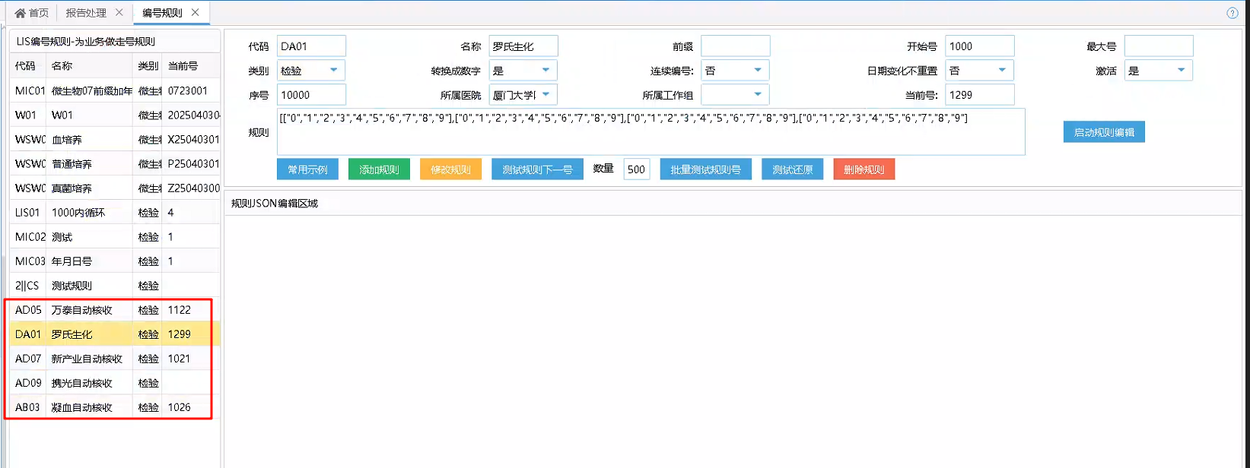​

[["0","1","2","3","4","5","6","7","8","9"],["0","1","2","3","4","5","6","7","8","9"],["0","1","2","3","4","5","6","7","8","9"],["0","1","2","3","4","5","6","7","8","9"]

/// Creator： YHR  
/// CreatDate： 20250320  
/// Description： 通过编号规则获取工作小组最大流水号  
/// Table： dbo.RPVisitNumberReport  
/// Input： 工作小组，日期(只能获取当天的，编号规则隔天后会刷新)  
/// Output： 无  
/// Return： 失败:"" 成功:流水号  
/// Others 【原】w ##Class(LIS.Common.DHCVisitNumber).GetMaxMiEpisodeNo("41","20250319")  
/// k ^TMP("MI.MIFIT3000N1.1","WGMEpis","41")  
/// w ##Class(MI.MIFIT3000N1).GetMaxMiEpisodeNo("41","20250403")  
ClassMethod GetMaxMiEpisodeNo(WorkGroupMachineDR As %String, TransmitDate As %String) As %String  
{  
 S TransmitDate=$g(TransmitDate)  
 S WorkGroupMachineDR=$G(WorkGroupMachineDR)  
 S RetValue=""  
 i '$l(WorkGroupMachineDR) q RetValue  
 i '$l(TransmitDate) s TransmitDate=$zd($h,8)  
 s TransmitDate=$tr(TransmitDate,"-")  
 s WorkGroupMachineCode=$lg(^dbo.BTWorkGroupMachineD(WorkGroupMachineDR),2)  
  
 //记录该工作小组当天最大的流水号，如果有记录，则优先判断是否核收成功，如果未核收成功仍旧使用该号码  
 i $d(^dbo.SYSRuleNoBaseI("IndexCode",WorkGroupMachineCode)) d  
 .s RuleNoBasDR=$o(^dbo.SYSRuleNoBaseI("IndexCode",WorkGroupMachineCode,""))  
 .s JLEpis=$lg($g(^dbo.SYSRuleNoBaseD(RuleNoBasDR)),5)  
 .i '$l(JLEpis) q  
 .i '$d(^dbo.RPVisitNumberReportI("IndexMicNo",WorkGroupMachineDR,JLEpis,TransmitDate)) d  
 ..s RetValue=JLEpis  
 i $l(RetValue) q RetValue  
  
 //通过编号规则获取当天流水号，编号规则代码设置为工作小组同样代码，通过代码获取工作小组对应的编号规则  
 s ZDHSEpis=##class(LIS.WS.BLL.DHCLISRuleNo).GetNextNoByCodeMTHD(WorkGroupMachineCode) //YHR 20230810 罗氏流水线规则  
 i $l(ZDHSEpis) d  
 .i '$d(^dbo.RPVisitNumberReportI("IndexMicNo",WorkGroupMachineDR,ZDHSEpis,TransmitDate)) d  
 ..s RetValue=ZDHSEpis  
 .e d  
 ..f Num=1:1:1000 d //避免死循环，每次进行一千次增号判断  
 ...s ZDHSEpis=##class(LIS.WS.BLL.DHCLISRuleNo).GetNextNoByCodeMTHD(WorkGroupMachineCode)  
 ...i '$d(^dbo.RPVisitNumberReportI("IndexMicNo",WorkGroupMachineDR,ZDHSEpis,TransmitDate)) d  
 ....s RetValue=ZDHSEpis  
 ....s Num=1001  
 i $l(RetValue) q RetValue  
  
 //未查询到编号规则，则获取当前工作小组最大流水号  
 s Parameter="<Data><P3></P3><P12></P12><P4></P4><P0>"_TransmitDate_"</P0><P8></P8><P10></P10><P5></P5><P1></P1><P13></P13><P9></P9><P14></P14><P6></P6><P2></P2><P11></P11><P7></P7></Data>"  
 s WGMEpisNo=##Class(LISSP.DHCRPVisitNumberReport).GetMaxEpisodeNo(WorkGroupMachineDR,Parameter) //YHR 20250317 获取最大流水号报错问题处理  
 i $l(WGMEpisNo) s RetValue=WGMEpisNo  
 q RetValue  
}

### 记录标本操作日志

记录仪器对于标本的操作日志，比如自动核收，上机，归档等信息

示例：j ..SaveRecord(epis,"归档中位置:"_positioninfo,mi,"62") //归档

此处62为操作表的Code，操作表为 dbo.BTOperatorType​

/// 记录标本日志  
/// D ##class(MI.MIFRS600).SaveRecord("","")  
ClassMethod SaveRecord(labno, OperateNotes, mi, OperateTypeCode, curWorkGroupMachineDR)  
{  
 s labno=$g(labno)  
 s OperateNotes=$g(OperateNotes)  
 s mi=$g(mi),curWorkGroupMachineDR=$g(curWorkGroupMachineDR)  
 s OperateTypeCode=$g(OperateTypeCode)  
 i '$l(curWorkGroupMachineDR),$l(mi) s curWorkGroupMachineDR=$lg($g(^dbo.BTMIMachineParameterD(mi)),6)  
 i $d(^dbo.RPVisitNumberI("IndexVisitNumber",##Class(LIS.Util.Common).IndexData(labno))) d  
 .s VisitNumberDR=$o(^dbo.RPVisitNumberI("IndexVisitNumber",##Class(LIS.Util.Common).IndexData(labno),""))  
 .//标本ID,操作时间,操作者,操作说明,操作类型,工作组,标本拒收类型  
 .//BTOperatorType 标本操作类型表  
 .d ##class(HIS.DHCCommon).SaveRecord(VisitNumberDR,$zd($h,8),$p($h,",",2),"",OperateNotes,OperateTypeCode,curWorkGroupMachineDR,"")  
}

### 存储报警信息标志

将报警信息存放到报告表中结果报警信息（ResultWarned）中，该字段为自动审核存储报警信息使用，未验证是否冲突。

​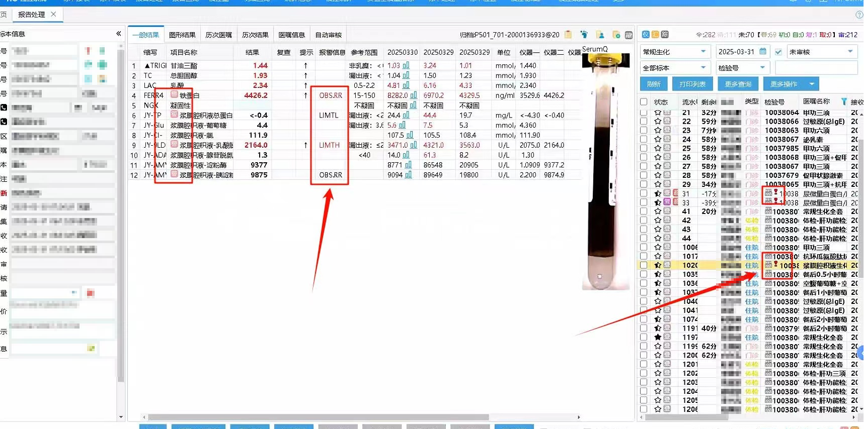​

​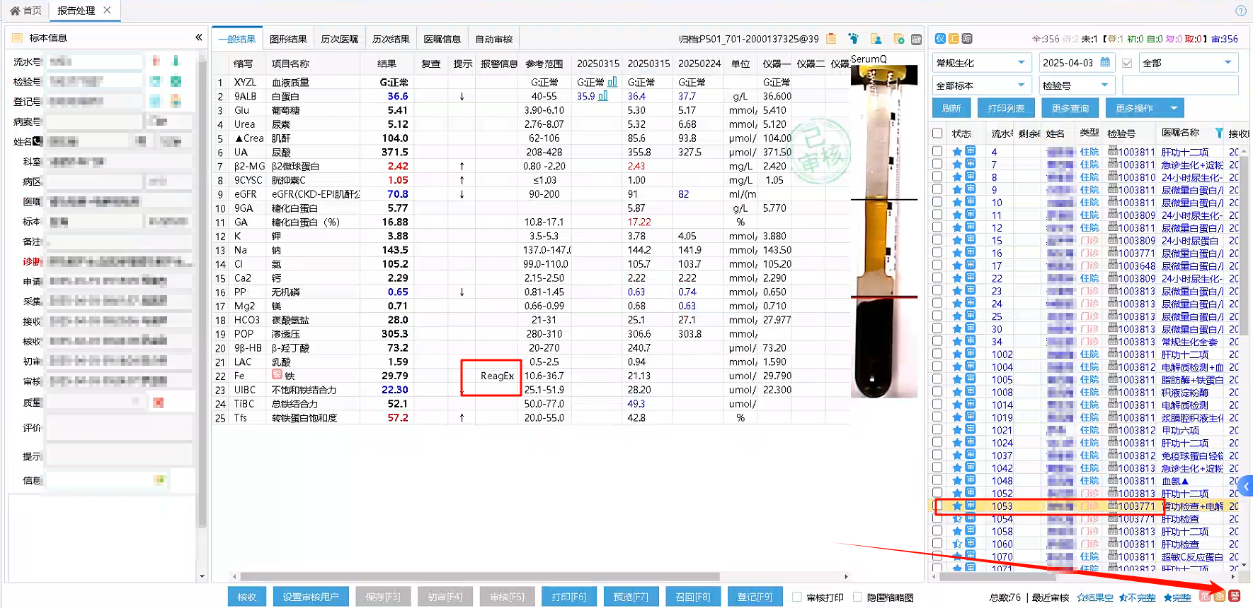​

​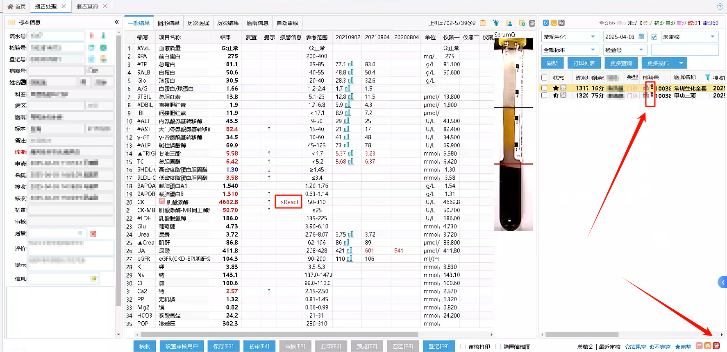​

​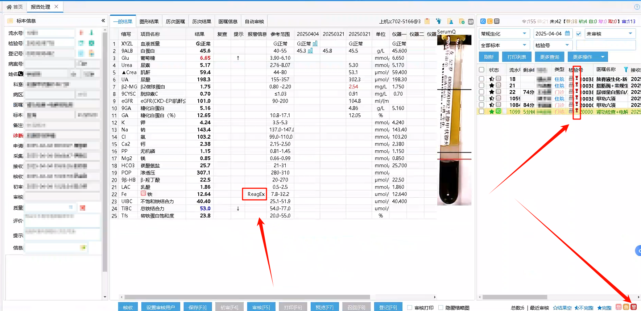​

/// 保存报告表报警信息标志  
/// D ##class(MI.MIFIT3000N1).SaveResultWarned("1003803130","1","34","41")  
ClassMethod SaveResultWarned(labno, conclusion, predealMI, curWorkGroupMachineDR)  
{  
 s labno=$g(labno)  
 s conclusion=$g(conclusion)  
 s predealMI=$g(predealMI),curWorkGroupMachineDR=$g(curWorkGroupMachineDR)  
 i '$l(curWorkGroupMachineDR) s curWorkGroupMachineDR=$lg($g(^dbo.BTMIMachineParameterD(predealMI)),6)  
 i $l(conclusion)>20 s conclusion=$e(conclusion,1,20)_"..."   
 s hasFindRep=0  
 i $d(^dbo.RPVisitNumberI("IndexVisitNumber",##Class(LIS.Util.Common).IndexData(labno))) d  
 .s VisitNumberDR=$o(^dbo.RPVisitNumberI("IndexVisitNumber",##Class(LIS.Util.Common).IndexData(labno),""))  
 .i $d(^dbo.RPVisitNumberReportI("IndexReportID",VisitNumberDR)) d  
 ..s WorkGroupMachineDR="" f s WorkGroupMachineDR=$o(^dbo.RPVisitNumberReportI("IndexReportID",VisitNumberDR,WorkGroupMachineDR)) q:WorkGroupMachineDR="" d  
 ...s OrderNo="" f s OrderNo=$o(^dbo.RPVisitNumberReportI("IndexReportID",VisitNumberDR,WorkGroupMachineDR,OrderNo)) q:OrderNo="" d  
 ....s ReportDR="" f s ReportDR=$o(^dbo.RPVisitNumberReportI("IndexReportID",VisitNumberDR,WorkGroupMachineDR,OrderNo,ReportDR)) q:ReportDR="" d  
 .....s Status=$lg($g(^dbo.RPVisitNumberReportD(ReportDR)),22)   
 .....i Status="3" q  
 .....s WorkGroupMachineDR=$lg($g(^dbo.RPVisitNumberReportD(ReportDR)),4)   
 .....s objrep=##Class(dbo.RPVisitNumberReport).%OpenId(ReportDR)  
 .....s objrep.ResultWarned=conclusion  
 .....s sc=objrep.%Save()  
 .....s hasFindRep=1  
 .....i ('$SYSTEM.Status.IsOK(sc)) d  
 ......d Trace^MI.MIF000(predealMI,"-1^存标本质量信息失败:"_$SYSTEM.Status.GetErrorText(sc),"H<--M")  
 i hasFindRep=0,$l(curWorkGroupMachineDR),$d(^dbo.RPVisitNumberReportI("IndexEpisodeNo",$zd($h,8),curWorkGroupMachineDR,##Class(LIS.Util.Common).IndexData(labno))) d  
 .s ReportDR=$o(^dbo.RPVisitNumberReportI("IndexEpisodeNo",$zd($h,8),curWorkGroupMachineDR,##Class(LIS.Util.Common).IndexData(labno),""))  
 .s objrep=##Class(dbo.RPVisitNumberReport).%OpenId(ReportDR)  
 .s objrep.ResultWarned=conclusion  
 .s sc=objrep.%Save()  
 .s hasFindRep=1  
 i hasFindRep=0 d Trace^MI.MIF000(predealMI,labno_":没有找到报告","H<--M")  
 q "1"  
}

基于此功能增加报告列表报警信息展示功能

#### 报警信息存储记录展示

仪器保存到报告表中结果报警信息后，在报告列表进行展示。只有非审核状态标本有此标志，其他状态显示报警信息标志。

后台增加输出结果报警信息字段

​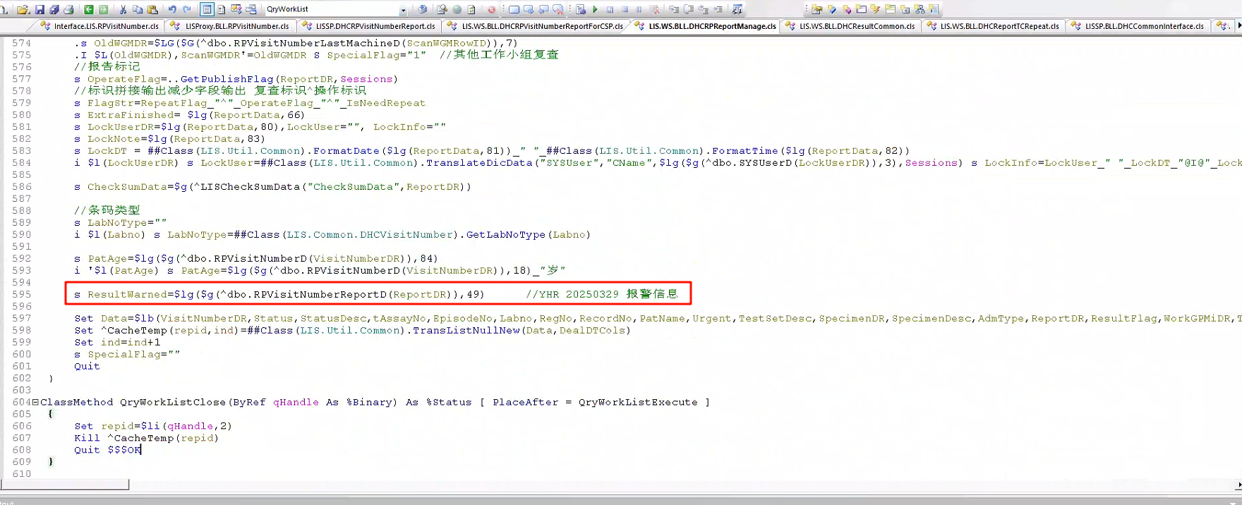​

s ResultWarned=$lg($g(^dbo.RPVisitNumberReportD(ReportDR)),49) //YHR 20250329 报警信息

​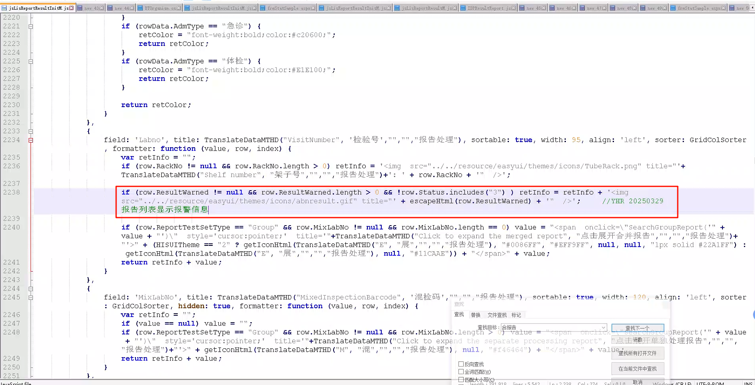​

if (row.ResultWarned != null && row.ResultWarned.length > 0 && !row.Status.includes("3") ) retInfo = retInfo + '<img src="../../resource/easyui/themes/icons/abnresult.gif" title="' + escapeHtml(row.ResultWarned) + '" />'; //YHR 20250329 报告列表显示报警信息

对于报警信息进行转义

function escapeHtml(unsafe) {  
 return unsafe  
 .replace(/&/g, "&amp;")  
 .replace(/</g, "&lt;")  
 .replace(/>/g, "&gt;")  
 .replace(/"/g, "&quot;")  
 .replace(/'/g, "&#039;");  
}

#### 报告处理增加筛选功能

可以快速对于含有报警信息的报告进行快速筛选

​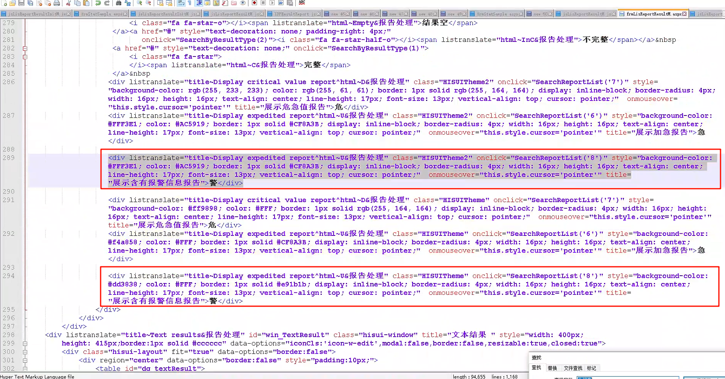​

<div listranslate="title~Display expedited report^html~U&报告处理" class="HISUITheme2" onclick="SearchReportList('8')" style="background-color: #FFF3E1; color: #AC5919; border: 1px solid #CF8A3B; display: inline-block; border-radius: 4px; width: 16px; height: 16px; text-align: center; line-height: 17px; font-size: 13px; vertical-align: top; cursor: pointer;" onmouseover="this.style.cursor='pointer'" title="展示含有报警信息报告">警</div>

<div listranslate="title~Display expedited report^html~U&报告处理" class="HISUITheme" onclick="SearchReportList('8')" style="background-color: #dd3838; color: #FFF; border: 1px solid #e91b1b; display: inline-block; border-radius: 4px; width: 16px; height: 16px; text-align: center; line-height: 17px; font-size: 13px; vertical-align: top; cursor: pointer;" onmouseover="this.style.cursor='pointer'" title="展示含有报警信息报告">警</div>

​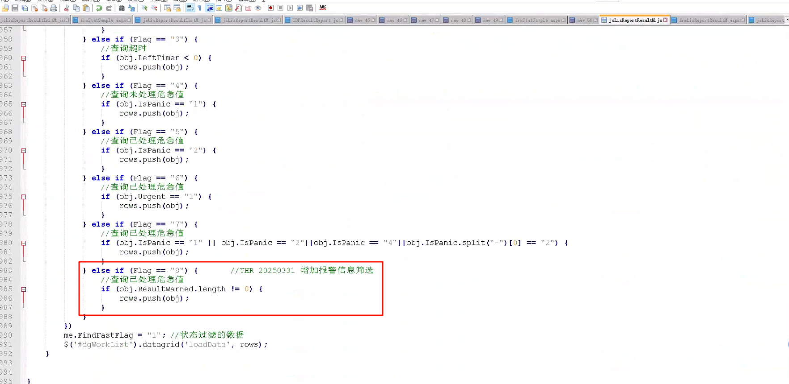​

else if (Flag == "8") { //YHR 20250331 增加报警信息筛选  
 //查询已处理危急值  
 if (obj.ResultWarned.length != 0) {  
 rows.push(obj);  
 }  
 }

### 存放报警信息或者评价信息

根据科室实际要求来，本接口只是将报警信息存放到其他结果字段，此方法只是扩展补充，将报警信息存放到主评价或者次评价

/// 保存评价信息(仪器报警信息等提示信息)  
/// 条码号或者流水号，存储信息，仪器主键，工作小组(仪器和工作小组非关联使用)，是否打印(1 主评价，0 次评价)  
/// D ##class(MI.Special.Common).SaveAlarmInformation("1003791311","Lymphopenia：淋巴细胞减少；Anemia：贫血；Reticulocytosis：网织红细胞增多","3")  
/// D ##class(MI.Special.Common).SaveAlarmInformation("8000001163","Monocytosis：单核细胞增加，Microcytosis：小红细胞症，Anemia：贫血，HGB Defect?：HGB异常？，IG present：幼稚粒细胞存在","77")  
ClassMethod SaveAlarmInformation(labno, conclusion, predealMI, curWorkGroupMachineDR, IsPrint)  
{  
 s labno=$g(labno),conclusion=$g(conclusion),predealMI=$g(predealMI),curWorkGroupMachineDR=$g(curWorkGroupMachineDR),IsPrint=$g(IsPrint)  
 i '$l(predealMI),'$l(curWorkGroupMachineDR) q ""  
 i IsPrint'=1 s IsPrint="0" //1 打印主评价，0 不打印次评价  
 i '$l(curWorkGroupMachineDR) s curWorkGroupMachineDR=$lg($g(^dbo.BTMIMachineParameterD(predealMI)),6)  
 s hasFindRep=0  
 i $d(^dbo.RPVisitNumberI("IndexVisitNumber",##Class(LIS.Util.Common).IndexData(labno))) d  
 .s VisitNumberDR=$o(^dbo.RPVisitNumberI("IndexVisitNumber",##Class(LIS.Util.Common).IndexData(labno),""))  
 .i $d(^dbo.RPVisitNumberReportI("IndexReportID",VisitNumberDR)) d  
 ..s WorkGroupMachineDR="" f s WorkGroupMachineDR=$o(^dbo.RPVisitNumberReportI("IndexReportID",VisitNumberDR,WorkGroupMachineDR)) q:WorkGroupMachineDR="" d  
 ...s OrderNo="" f s OrderNo=$o(^dbo.RPVisitNumberReportI("IndexReportID",VisitNumberDR,WorkGroupMachineDR,OrderNo)) q:OrderNo="" d  
 ....s ReportDR="" f s ReportDR=$o(^dbo.RPVisitNumberReportI("IndexReportID",VisitNumberDR,WorkGroupMachineDR,OrderNo,ReportDR)) q:ReportDR="" d  
 .....s Status=$lg($g(^dbo.RPVisitNumberReportD(ReportDR)),22)   
 .....;i Status="3" q //审核后的标本存储报警信息，测试用  
 .....s WorkGroupMachineDR=$lg($g(^dbo.RPVisitNumberReportD(ReportDR)),4)   
 .....s objrep=##Class(dbo.RPVisitNumberReport).%OpenId(ReportDR)  
 .....i IsPrint=1 d  
 ......i $l(objrep.MajorConclusion) s objrep.MajorConclusion=objrep.MajorConclusion_","_conclusion  
 ......e s objrep.MajorConclusion=conclusion  
 .....e d  
 ......i $l(objrep.MinorConclusion) s objrep.MinorConclusion=objrep.MinorConclusion_","_conclusion  
 ......e s objrep.MinorConclusion=conclusion  
 .....s sc=objrep.%Save()  
 .....s hasFindRep=1  
 .....i ('$SYSTEM.Status.IsOK(sc)) d  
 ......d Trace^MI.MIF000(predealMI,"-1^存标本质量信息失败:"_$SYSTEM.Status.GetErrorText(sc),"H<--M")  
 i hasFindRep=0,$l(curWorkGroupMachineDR),$d(^dbo.RPVisitNumberReportI("IndexEpisodeNo",$zd($h,8),curWorkGroupMachineDR,##Class(LIS.Util.Common).IndexData(labno))) d  
 .s ReportDR=$o(^dbo.RPVisitNumberReportI("IndexEpisodeNo",$zd($h,8),curWorkGroupMachineDR,##Class(LIS.Util.Common).IndexData(labno),""))  
 .s objrep=##Class(dbo.RPVisitNumberReport).%OpenId(ReportDR)  
 .i IsPrint=1 d  
 ..s objrep.MajorConclusion=conclusion  
 .e s objrep.MinorConclusion=conclusion  
 .s sc=objrep.%Save()  
 .s hasFindRep=1  
 i hasFindRep=0 d Trace^MI.MIF000(predealMI,labno_":没有找到报告","H<--M")  
 try{D ##class(MI.Special.Common).SaveResultWarned(labno,conclusion,predealMI, curWorkGroupMachineDR)}catch{} //保存至报告表报警信息  
 q "1"  
}

### 存储架子号信息以及标本操作日志记录

标本在流水线上有分区，上机，标本位置变化和标本归档等操作。之前查询标本位置需要在仪器软件上进行搜索查看，基于流水线本身会传输标本在流水线上的相关信息，因此对于这些信息解析。并将这些信息，存放至标本操作日志，将标本当前位置存放至架子号。

本初增加额外的标本操作类型，101，架子号更新，避免仪器传错信息，仍旧可以有地方记录查看。

/// 保存归档,分类信息,架子号,新增保存类型和参数工作小组ID，针对仪器不在对应的工作小组也可以保存架子号。  
/// D ##class(MI.Special.Common).SaveRackNo(labno, positioninfo, mi, typename, curWorkGroupMachineDR)  
/// D ##class(MI.Special.Common).SaveRackNo("1003775669","c702-5719@4","34","上机")  
/// D ##class(MI.Special.Common).SaveRackNo("1003807721","新产业-NA024-2","45","上机")  
ClassMethod SaveRackNo(labno, positioninfo, mi, typename, curWorkGroupMachineDR)  
{  
 s labno=$g(labno)  
 s positioninfo=$g(positioninfo)  
 s mi=$g(mi),curWorkGroupMachineDR=$g(curWorkGroupMachineDR),typename=$g(typename)  
 i '$L(curWorkGroupMachineDR) s curWorkGroupMachineDR=$lg($g(^dbo.BTMIMachineParameterD(mi)),6)  
 i $l(typename) s positioninfo=typename_":"_positioninfo  
 s hasFindRep=0  
 i $d(^dbo.RPVisitNumberI("IndexVisitNumber",##Class(LIS.Util.Common).IndexData(labno))) d  
 .s VisitNumberDR=$o(^dbo.RPVisitNumberI("IndexVisitNumber",##Class(LIS.Util.Common).IndexData(labno),""))  
 .i $d(^dbo.RPVisitNumberReportI("IndexReportID",VisitNumberDR)) d  
 ..s WorkGroupMachineDR="" f s WorkGroupMachineDR=$o(^dbo.RPVisitNumberReportI("IndexReportID",VisitNumberDR,WorkGroupMachineDR)) q:WorkGroupMachineDR="" d  
 ...s OrderNo="" f s OrderNo=$o(^dbo.RPVisitNumberReportI("IndexReportID",VisitNumberDR,WorkGroupMachineDR,OrderNo)) q:OrderNo="" d  
 ....s ReportDR="" f s ReportDR=$o(^dbo.RPVisitNumberReportI("IndexReportID",VisitNumberDR,WorkGroupMachineDR,OrderNo,ReportDR)) q:ReportDR="" d  
 .....s WorkGroupMachineDR=$lg($g(^dbo.RPVisitNumberReportD(ReportDR)),4)   
 .....s objrep=##Class(dbo.RPVisitNumberReport).%OpenId(ReportDR)  
 .....i typename["上机" try{j ..SaveRecord(labno,positioninfo,mi,"6")}catch{}  
 .....i $l(objrep.RackNo),objrep.RackNo'=positioninfo try{j ..SaveRecord(labno,"架子号位置更新:"_objrep.RackNo_"-->"_positioninfo,mi,"101")}catch{} //架子号更新  
 .....s objrep.RackNo=positioninfo  
 .....s sc=objrep.%Save()  
 .....s hasFindRep=1  
 .....i ('$SYSTEM.Status.IsOK(sc)) d  
 ......d Trace^MI.MIF000(mi,"-1^存"_typename_"信息失败:"_$SYSTEM.Status.GetErrorText(sc),"H<--M")  
 i hasFindRep=0,$d(^dbo.RPVisitNumberReportI("IndexEpisodeNo",$zd($h,8),curWorkGroupMachineDR,##Class(LIS.Util.Common).IndexData(labno))) d  
 .s ReportDR=$o(^dbo.RPVisitNumberReportI("IndexEpisodeNo",$zd($h,8),curWorkGroupMachineDR,##Class(LIS.Util.Common).IndexData(labno),""))  
 .s objrep=##Class(dbo.RPVisitNumberReport).%OpenId(ReportDR)  
 .i typename["上机" try{j ..SaveRecord(labno,positioninfo,mi,"6")}catch{}  
 .i $l(objrep.RackNo),objrep.RackNo'=positioninfo try{j ..SaveRecord(labno,"架子号位置更新:"_objrep.RackNo_"-->"_positioninfo,mi,"101")}catch{} //架子号更新  
 .s objrep.RackNo=positioninfo  
 .s sc=objrep.%Save()  
 .s hasFindRep=1  
 i hasFindRep=0 d Trace^MI.MIF000(mi,labno_":没有找到报告","H<--M")  
 q hasFindRep  
}

### 存储标本图片

罗氏流水线有血清标本图片，图片命名格式为条码号_第几个，比如1003783657_01，标本重复上线时会出现多个标本图片的情况，此处抓图将多个图片都抓取，按照P1，P2保存至标本图片表，如果找不到哦啊对应标本，则存入仪器图片表。

/// 保存标本图片  
/// D ##class(MI.MIFRS600).SaveImageMTHD("57","1000100990","P","/iLISLIS080/demo.png","","","","","","","","","","","")  
/// D ##class(MI.MIFIT3000N1).SaveImageMTHD("34","1003783657_01","1003783657_01","/iLISLIS032/20250321/1003783657_01.jpg","C:\LISDATA\DATA\1003783657_01.jpg","","","","","","","","","","")  
ClassMethod SaveImageMTHD(mi, epis, ImageClass, FileName, P4, P5, P6, P7, P8, P9, P10, P11, P12, P13, Sessions, Output RowCount As %String) As %String  
{  
 s ^YHR("MI.MIFIT3000")=$lb(mi, epis, ImageClass, FileName, P4, P5, P6, P7, P8, P9, P10, P11, P12, P13, Sessions)  
 s mi=$g(mi)  
 s mi=mi  
 s ret="1"  
 s epis=$p(epis,"_",1)  
 s ImageClass="P"_+$p(ImageClass,"_",2)  
 i '$d(^dbo.BTMIMachineParameterD(mi)) q ""  
 //标本血清质量特殊处理  
 i $d(^dbo.RPVisitNumberI("IndexVisitNumber",##Class(LIS.Util.Common).IndexData(epis))) d   
 .s obj=""  
 .s VisitNumberDR=$o(^dbo.RPVisitNumberI("IndexVisitNumber",##Class(LIS.Util.Common).IndexData(epis),""))  
 .i $d(^dbo.RPVisitNumberImageI("IndexMaster",VisitNumberDR,##Class(LIS.Util.Common).IndexData("SerumQ"),##Class(LIS.Util.Common).IndexData(ImageClass))) d  
 ..s RowID="" f s RowID=$o(^dbo.RPVisitNumberImageI("IndexMaster",VisitNumberDR,##Class(LIS.Util.Common).IndexData("SerumQ"),##Class(LIS.Util.Common).IndexData(ImageClass),RowID)) q:RowID="" d  
 ...s obj=##class(dbo.RPVisitNumberImage).%OpenId(RowID)  
 .i '$l(obj) s obj=##class(dbo.RPVisitNumberImage).%New()  
 .s obj.VisitNumberDR=VisitNumberDR  
 .s obj.ImageClass="SerumQ"  
 .s obj.ImageID=ImageClass  
 .s obj.FileName=FileName  
 .s sc=obj.%Save()  
 .i ('$SYSTEM.Status.IsOK(sc)) d  
 ..s ret= "-1^保存报告图片失败:"_$SYSTEM.Status.GetErrorText(sc)  
 e d  
 .d Trace^MI.MIF000(mi,epis_":"_ImageClass_":"_FileName,"H<--M")  
 .s (ReceiveDate, ImageOrder, Caption, DisplayRatio, Height, Width, Sequence)=""  
 .s ret=##Class(MI.Common.MachineResult).SaveImage(ReceiveDate, epis, ImageClass, ImageOrder, FileName, mi, Caption, DisplayRatio, Height, Width, Sequence)  
 q ret  
}

基于此功能附加功能

#### 血清标本显示

抓取血清图片后，会有多张图片的情况，将最新的图片显示在最上边

修改方法 "LIS.WS.BLL.DHCRPVisitNumberReport","QryReportImage"

k ^LISVisitNumberImage("Data")  
 //获取条码标本质量图形信息  
 i $d(^dbo.RPVisitNumberImageI("IndexMaster",VisitNumberDR,##Class(LIS.Util.Common).IndexData("SerumQ"))) D  
 .s SERUMID=""  
 .f S SERUMID=$O(^dbo.RPVisitNumberImageI("IndexMaster",VisitNumberDR,##Class(LIS.Util.Common).IndexData("SerumQ"),SERUMID)) q:SERUMID="" d   
 ..S SERUMQRowID=$O(^dbo.RPVisitNumberImageI("IndexMaster",VisitNumberDR,##Class(LIS.Util.Common).IndexData("SerumQ"),SERUMID,""))   
 ..S (FileName,MachineParameterDR,Caption,DisplayRatio,Height,Width,Sequence,ImageClassDesc) = ""  
 ..S StrData=$g(^dbo.RPVisitNumberImageD(SERUMQRowID))  
 ..s RowID=SERUMQRowID  
 ..s ImageClassDesc = $lg(StrData,4)  
 ..s FileName = ftp_$lg(StrData,5)  
 ..s ThumbnailWidth="",ThumbnailHeight="",ThumbnailDeg=""  
 ..s Caption = "SerumQ"  
 ..s IsImageRes=""  
 ..s IsExistImgRes=""  
 ..s Time=$p($h,",",2)  
 ..s FileName=FileName //_"?Version="_Time //解决图片缓存问题  
 ..Set Data=$lb(ImageClassDesc,ImageOrder,FileName,MachineParameterDR,Caption,DisplayRatio,Height,Width,Sequence,RowID,IsImageRes,ThumbnailWidth,ThumbnailHeight,ThumbnailDeg)  
 ..s ^LISVisitNumberImage("Data",ImageClassDesc)=Data  
 ..;d OutputRow  
  
 /*---------->设置血清标本只显示最新的开始<----------*/  
 i $d(^LISVisitNumberImage("Data")) d  
 .s ImageClassDesc=$o(^LISVisitNumberImage("Data",""),-1)  
 .s Data=$g(^LISVisitNumberImage("Data",ImageClassDesc))  
 .s Caption=$lg(Data,5)  
 .s ImageClassDescNext=$o(^LISVisitNumberImage("Data",ImageClassDesc),-1)  
 .i $l(ImageClassDescNext) s $li(Data,5)=Caption_"-"_ImageClassDesc  
 .i '$l(Sequence) s Sequence=999  
 .i '$l(RowID) q  
 .s ^TMP($zn,repid,$j,Sequence,RowID)=Data  
 k ^LISVisitNumberImage("Data")  
 /*---------->设置血清标本只显示最新的结束<----------*/

## 特殊处理记录

本节点为该仪器接口特殊处理的部分，可以参考实际修改使用

### 监听配置，有多条监听配置

主监听配置会获取仪器主键，其他的无法获取只能写死，主键有根据项目实际情况修改

​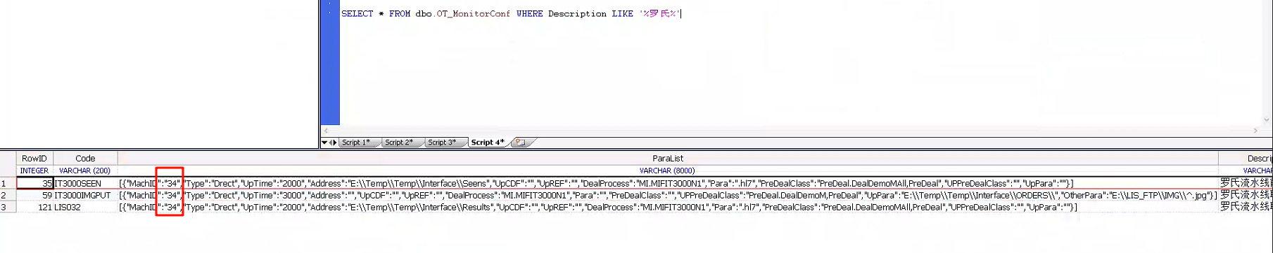​

### 自动核收调用核收方法，按照工作小组主键入参。

​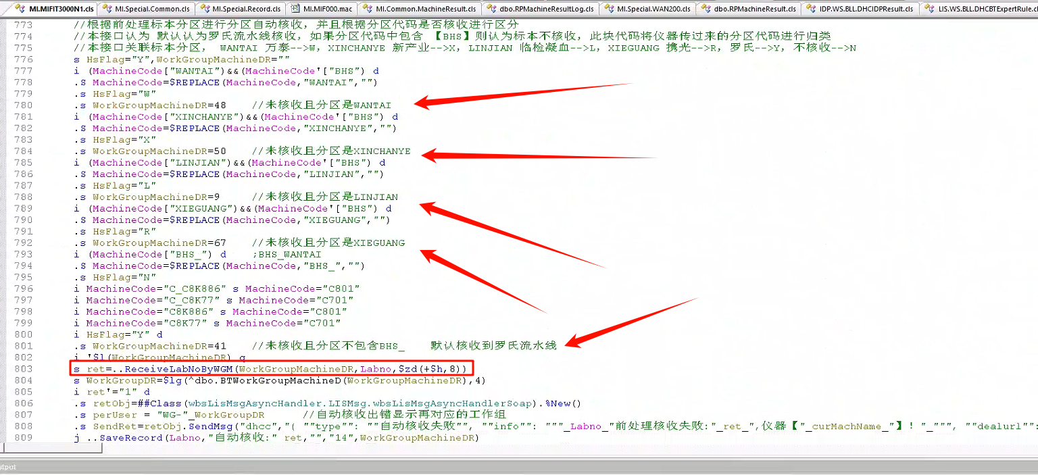​

### 自动核收前处理

由于自动核收功能包括罗氏本流水线自动核收，同时还带有分拣功能，对于免疫标本和临检标本分区和自动核收。本部分为特殊处理部分。

本部分分为两块，一块为接收时上传维护，此部分与科室进行核对维护，另一部分为接收分区标识，根据仪器分区进行核收。（注：未通过检验自己维护的项目分区进行核收，一部分是减少调用增加处理速度，另一部分是根据仪器分区，方便科室对应分区找到对应工作小组的标本。）

1.生化的标本都会立马拔盖上机去做，对于其他的标本，比如免疫和临检的标本，涉及到是否拔盖和分区的逻辑。仪器分别该标本类型，则需要通过检验上传对应条码的相关信息，因此，在流水线工作组中，对应医嘱维护不同的检测项目，在接收的时候就会获取流水线的医嘱对应的项目，在上传通道号维护对应的标识。

​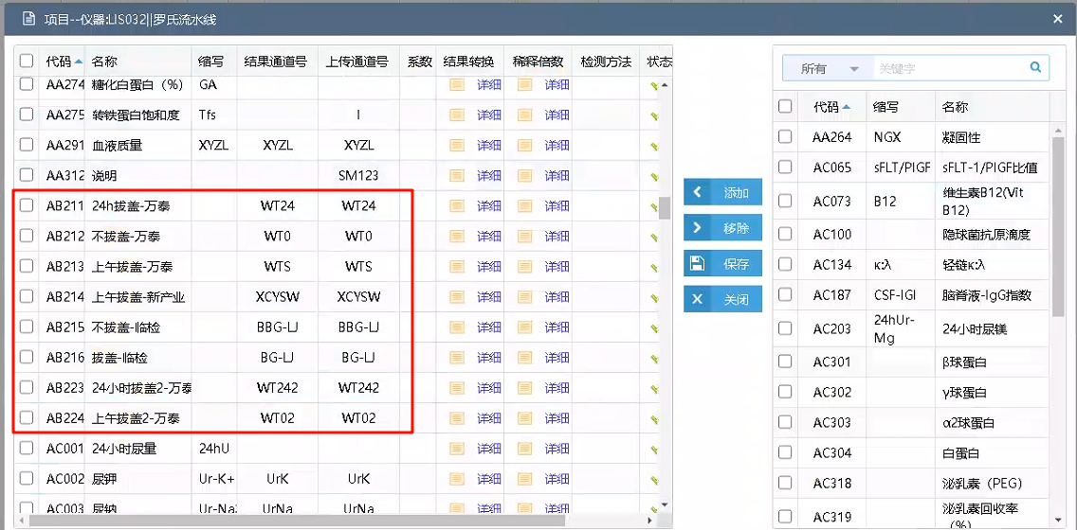​

​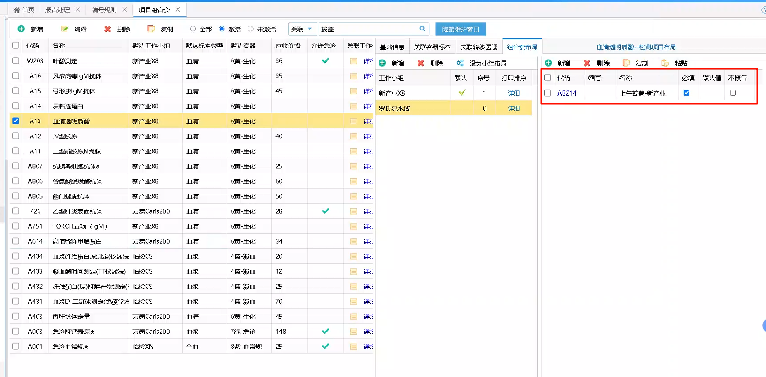​

2.标本上机仪器回传分区标识进行自动核收

优先判断是否已接收未核收，如果已经核收则直接退出。

根据前处理标本分区标识进行自动核收（此标识跟仪器进行核对不同的分区标识），通过不同的标识获取对应的工作小组，或者BHS_标识只记录分区不进行核收。核收失败进行弹窗提示。

记录自动核收操作日志。

​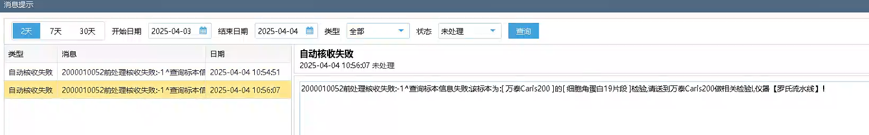​

/// 仪器主键，条码号，前处理标本分区标识，仪器信息(位置)  
/// w ##class(MI.MIFIT3000N1).ZDHS("34","8000000352","WANTAI")  
/// w ##class(MI.MIFIT300N).ZDHS("34","1003779663","RSA1")  
ClassMethod ZDHS(mi, Labno, MachineCode, positioninfo)  
{  
 s mi=$g(mi),Labno=$g(Labno),machCode=$g(MachineCode),positioninfo=$g(positioninfo)  
 i '$l(Labno) q ""  
 /*---------->判断该标本是否已接收未核收 开始<----------*/  
 s QuitFlag=0  
 i $d(^dbo.RPVisitNumberI("IndexVisitNumber",##class(LIS.Util.Common).IndexData(Labno))) d  
 .s VisitNumberDR=$o(^dbo.RPVisitNumberI("IndexVisitNumber",##class(LIS.Util.Common).IndexData(Labno),""))  
 .i $d(^dbo.RPVisitNumberReportI("IndexReportID",VisitNumberDR)) s QuitFlag=1  
 i QuitFlag=1 q ""  
 /*---------->判断该标本是否已接收未核收 结束<----------*/  
 s curWorkGroupMachineDR=$lg($g(^dbo.BTMIMachineParameterD(mi)),6) //得到当前仪器关联工作小组信息  
 s CurWorkGroupDR=$lg(^dbo.BTWorkGroupMachineD(curWorkGroupMachineDR),4)  
 s curMachName=$lg($g(^dbo.BTMIMachineParameterD(mi)),5)  
 s AcceptFlag=$lg($g(^dbo.BTWorkGroupMachineD(curWorkGroupMachineDR)),13) //得到仪器工作小组的核收类型  
   
 //AcceptFlag为1认为是前处理工作小组，如果是前处理小组，就认为上前处理 本接口未设置前处理工作小组，未对此流程进行测试  
 i AcceptFlag="1" d QCLZDHS  
 e d ZDHS  
 q ""  
   
ZDHS  
 d Trace^MI.MIF000(mi,"上仪器,标本号:"_Labno_"的标本在:"_curMachName_",分区位置:"_MachineCode_",样本所在:"_positioninfo,"自动核收")  
  
 //根据前处理标本分区进行分区自动核收，并且根据分区代码是否核收进行区分  
 //本接口认为 默认认为罗氏流水线核收，如果分区代码中包含 【BHS】则认为标本不核收，此块代码将仪器传过来的分区代码进行归类  
 //本接口关联标本分区， WANTAI 万泰-->W，XINCHANYE 新产业-->X，LINJIAN 临检凝血-->L，XIEGUANG 携光-->R，罗氏-->Y，不核收-->N  
 s HsFlag="Y",WorkGroupMachineDR=""  
 i (MachineCode["WANTAI")&&(MachineCode'["BHS") d  
 .S MachineCode=$REPLACE(MachineCode,"WANTAI","")  
 .s HsFlag="W"  
 .s WorkGroupMachineDR=48 //未核收且分区是WANTAI  
 i (MachineCode["XINCHANYE")&&(MachineCode'["BHS") d  
 .S MachineCode=$REPLACE(MachineCode,"XINCHANYE","")  
 .s HsFlag="X"  
 .s WorkGroupMachineDR=50 //未核收且分区是XINCHANYE  
 i (MachineCode["LINJIAN")&&(MachineCode'["BHS") d  
 .S MachineCode=$REPLACE(MachineCode,"LINJIAN","")  
 .s HsFlag="L"  
 .s WorkGroupMachineDR=9 //未核收且分区是LINJIAN  
 i (MachineCode["XIEGUANG")&&(MachineCode'["BHS") d  
 .S MachineCode=$REPLACE(MachineCode,"XIEGUANG","")  
 .s HsFlag="R"  
 .s WorkGroupMachineDR=67 //未核收且分区是XIEGUANG  
 i (MachineCode["BHS_") d ;BHS_WANTAI  
 .S MachineCode=$REPLACE(MachineCode,"BHS_","")  
 .s HsFlag="N"  
 i MachineCode="C_C8K886" s MachineCode="C801"  
 i MachineCode="C_C8K77" s MachineCode="C701"  
 i MachineCode="C8K886" s MachineCode="C801"  
 i MachineCode="C8K77" s MachineCode="C701"  
 i HsFlag="Y" d  
 .s WorkGroupMachineDR=41 //未核收且分区不包含BHS_ 默认核收到罗氏流水线  
 i '$l(WorkGroupMachineDR) q  
 s ret=..ReceiveLabNoByWGM(WorkGroupMachineDR,Labno,$zd(+$h,8))  
 s WorkGroupDR=$lg(^dbo.BTWorkGroupMachineD(WorkGroupMachineDR),4)  
 i ret'="1" d  
 .s retObj=##Class(wbsLisMsgAsyncHandler.LISMsg.wbsLisMsgAsyncHandlerSoap).%New()  
 .s perUser = "WG-"_WorkGroupDR //自动核收出错显示再对应的工作组  
 .s SendRet=retObj.SendMsg("dhcc","{ ""type"": ""自动核收失败"", ""info"": """_Labno_"前处理核收失败:"_ret_",仪器【"_curMachName_"】！"_""", ""dealurl"": """" }", "Crisis", perUser)  
 j ..SaveRecord(Labno,"自动核收:"_ret,"","14",WorkGroupMachineDR)  
 q ret  
  
QCLZDHS  
 d Trace^MI.MIF000(mi,"上前处理，鉴定号:"_Labno_"的标本在:"_curMachName_",样本所在:"_positioninfo,"DealInfo")  
 d Trace^MI.MIF000(mi,"执行核收到前处理","DealInfo")  
 //此处核收医嘱导前处理工作小组，不生成项目，写标本操作日志  
 s dealret=##Class(LIS.Common.DHCVisitNumber).PreDealLabNo(mi,Labno,"")   
 d Trace^MI.MIF000(mi,Labno_"核收到前处理返回信息:"_dealret,"DealInfo")  
 //记录位置信息到报告位置号  
 d ..SaveRackNo(Labno,positioninfo,mi)  
 i dealret["标本已核收" q   
 i dealret="1" d  
 .//写标本操作日志  
 .d ..SaveRecord(Labno,machCode,mi,"5")  
 e d  
 .s retObj=##Class(wbsLisMsgAsyncHandler.LISMsg.wbsLisMsgAsyncHandlerSoap).%New()  
 .s perUser = "WG-"_CurWorkGroupDR  
 .s ret=retObj.SendMsg("dhcc","{ ""type"": ""自动核收失败"", ""info"": """_Labno_"前处理核收失败:"_dealret_",仪器【"_curMachName_"】！"_""", ""dealurl"": """" }", "Crisis", perUser)  
 .//写标本操作日志  
 .d ..SaveRecord(Labno,dealret,mi,"100")  
 q  
}

### 特殊结果的转换

仪器某些结果需要进行转换，固定的大部分都可以通过仪器维护对应项目的系数进行转换，但是对于包含><的无法进行转换，因此需要在接口里进行特殊处理。

！！！注：系数为除法

​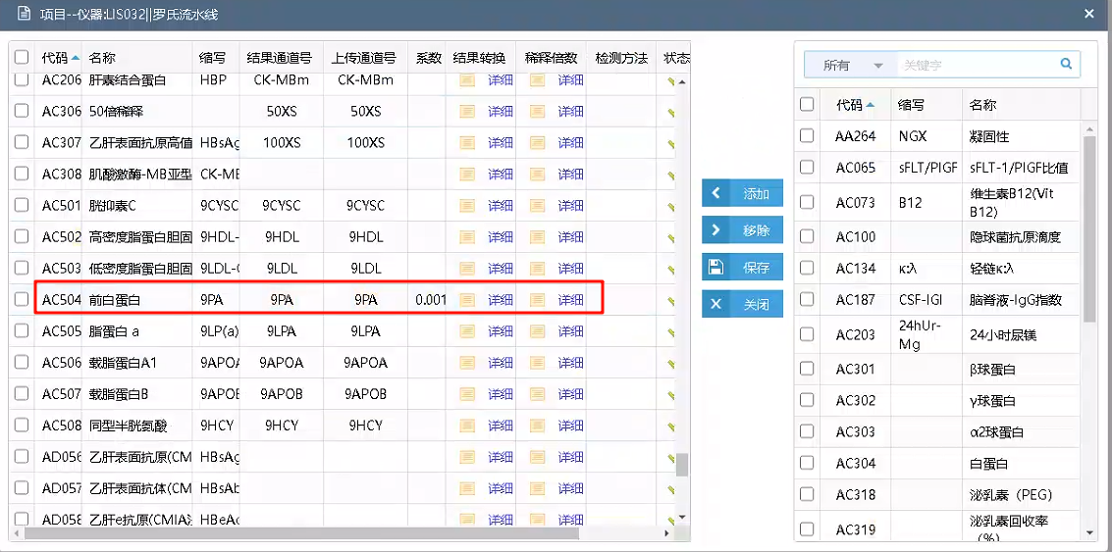​

/// 结果特殊转换  
/// $TS$  
/// W ##CLASS(MI.MIFIT3000N1).ConvertResult("9PA","<0.070")  
ClassMethod ConvertResult(code, res)  
{  
 i code="9PA" d  
 .i $e(res)="<",+$e(res,2,*)=".07" d  
 ..s res="<70"  
 q res  
}

### 报警信息转换

本接口未使用报警信息转换，仪器传过来的报警信息就是转换后的报警信息，此处只是作为记录。

/// 报警信息转换  
ClassMethod ConvertPoliceInfo(WaringCode)  
{  
 s WaringStr=""  
 i WaringCode="5" s WaringStr=">ABS(超出ABS)"  
 i WaringCode="43" s WaringStr="Cal.E(校准结果异常)"  
 i WaringCode="2" s WaringStr=">Cuvet(反应杯空白异常)"  
 i WaringCode="42" s WaringStr="Edit(实验结果已被编辑)"  
 i WaringCode="23" s WaringStr=">ISE(超出ISE范围)"  
 i WaringCode="19" s WaringStr="ISE.E(ISE电压级错误)"  
 i WaringCode="56" s WaringStr=">Kin(Prozone错误2/运动不稳)"  
 i WaringCode="10" s WaringStr=">Lin(线性异常)"  
 i WaringCode="11" s WaringStr=">Lin(线性异常)"  
 i WaringCode="6" s WaringStr=">Prozone(Prozone错误1)"  
 i WaringCode="4" s WaringStr="Reag.S(试剂不足)"  
 i WaringCode="44" s WaringStr=">Rept(高出原倍复查范围)"  
 i WaringCode="45" s WaringStr="<Rept(低于原倍复查范围)"  
 i WaringCode="46" s WaringStr="Samp.？(高出ABS最大值)"  
 i WaringCode="68" s WaringStr="Samp.B(样本中有气泡)"  
 i WaringCode="72" s WaringStr="Samp.C(样本中有凝块)"  
 i WaringCode="26" s WaringStr=">Test(高出线性范围)"  
 i WaringCode="27" s WaringStr="<Test(低于线性范围)"  
 q WaringStr  
}

### 新增标本操作日志记录类型

新增两个操作类型

100 前处理分区  
101 架子号更新

​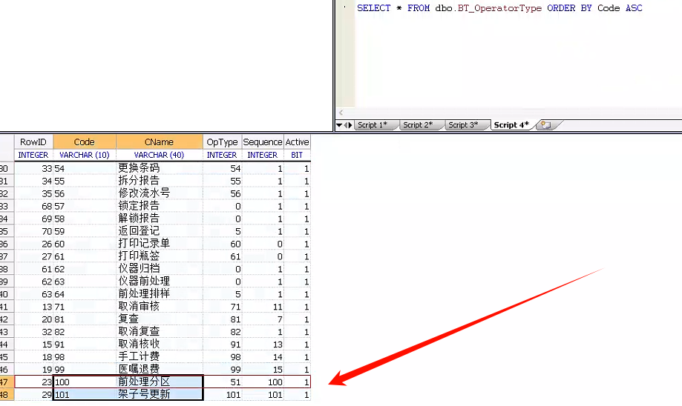​

### 主动上传特殊处理

包含申请项目上传，复查项目上传，回退项目上传和审核项目上传

申请状态为C，复查状态为U，回退状态为R，审核状态为T

申请状态和审核状态进行分批上传，分别同时超过10个就先输出这10个，再次查询时再进行新的查询

申请为重新获取项目，避免漏项目，如果要提升速度，则修改为获取上传表通道号，复查为获取上传表通道号(跟踪后发现也为发送全部为空的数据，并不是只复查需要复查的项目)，回退项目为获取标本对应医嘱所关联的工作小组布局和组合套布局（要求输入全部的项目才能完全删除仪器不做的项目，只传部分的话只删除上传的项目），审核上传为固定的通道项目

/// Creator： 查询患者信息，监听配置上传前处理类后会定时调用这个query查询数据进行上传操作  
/// CreatDate： 20140919  
/// Description:：   
/// Table：   
  
/// Input： mi：仪器主键  
/// Output： 仪器信息  
/// Return： 仪器信息  
/// Others：   
  
Query QryLabInfo(mi As %String, P1, P2, P3, P4, P5, P6, P7, P8, P9, P10, P11, P12, P13, Sessions, Output RowCount As %String) As %Query(ROWSPEC = "labno,labnoInfo,patInfo")  
{  
}  
  
/// Query的执行方法  
/// d ##class(%ResultSet).RunQuery("MI.MIFIT3000N1","QryLabInfo","34","","","","","","","","","","","","","","","")  
ClassMethod QryLabInfoExecute(ByRef qHandle As %Binary, mi As %String, P1, P2, P3, P4, P5, P6, P7, P8, P9, P10, P11, P12, P13, Sessions, Output RowCount As %String) As %Status  
{  
 Set repid=$i(^CacheTemp)  
 Set ind=1  
 s mi=$g(mi),flag=$g(flag)  
 i '$d(^dbo.BTMIMachineParameterD(mi)) q ""  
 s LabnoList=""  
 s VisitNumberDR=""  
 s OutPutNum=0  
 //*-------------------------------->*申请项目  
 s AddDate=$zd($p($h,",",1)-1,8) f s AddDate=$o(^dbo.RPMachineUploadI("IndexSendStatus",mi,##Class(LIS.Util.Common).IndexData("C"),AddDate)) q:(AddDate="")||(OutPutNum>6) d  
 .s AddTime="" f s AddTime=$o(^dbo.RPMachineUploadI("IndexSendStatus",mi,##Class(LIS.Util.Common).IndexData("C"),AddDate,AddTime)) q:(AddTime="")||(OutPutNum>6) d  
 ..s OutPutNum=OutPutNum+1  
 ..s MiUploadDR=$o(^dbo.RPMachineUploadI("IndexSendStatus",mi,##Class(LIS.Util.Common).IndexData("C"),AddDate,AddTime,""))  
 ..s labno=$lg(^dbo.RPMachineUploadD(MiUploadDR),3)  
 ..;s EpisNo=$$getEpis^MI.MIF000(labno,mi)  
 ..;i '$l(EpisNo) q  
 ..i '$l(labno) q  
 ..i '$d(^dbo.RPVisitNumberI("IndexVisitNumber",labno)) q  
 ..s VisitNumberDR=$o(^dbo.RPVisitNumberI("IndexVisitNumber",labno,""))  
 ..i '$l(VisitNumberDR) q  
 ..s ReceiveTime=$lg($g(^dbo.RPVisitNumberD(VisitNumberDR)),67)  
 ..i ((+$p($h,",",2))-ReceiveTime>=-2)&&((+$p($h,",",2))-ReceiveTime<5) d Trace^MI.MIF000(mi,labno_"标本接收时间低于5秒不上传","等待上传") q  
 ..//得到通道号  
 ..s patInfo=..GetPatInfo(mi,labno)  
 ..s PatName=$p(patInfo,",",10)  
 ..//控制输出文本的内容  
 ..s labnoInfo=..GetLabnoInfo(mi,labno)_"@C" //重新获取通道号 避免因为接收造成漏项目  
 ..;GetLabnoInfoDelete  
 ..;s TCList=$lg(^dbo.RPMachineUploadD(MiUploadDR),7)  
 ..;s labnoInfo=labno_","_$replace(TCList,"\","+")_"|@U"  
 ..s txtInfo=..GetLabnoInfoN(mi,labnoInfo,patInfo)  
 ..s now=$now()  
 ..s filenametime=$zd($p(now,",",1),8)_$tr($zt($p(now,",",2)),":")_$p(now,".",2)  
 ..s filename=filenametime_"_"_labno_".hl7"  
 ..s Data=##class(MI.Common.MIFBase).DemoMOutFileInfo(filename,txtInfo,labno,1,"")  
 ..d Trace^MI.MIF000(mi,txtInfo,"申请上传信息")  
 ..d OutputRow  
 ..try{d ##class(MI.Special.Record).RecordData(labno,"C@"_##Class(LIS.Util.Common).GetClientIP()_txtInfo,"LSLSXPUT",1,1,10)}catch{} //YHR 20230828 记录十天的数据  
 //*-------------------------------->*复查结果上传  
 s AddDate=$zd($p($h,",",1)-2,8) f s AddDate=$o(^dbo.RPMachineUploadI("IndexSendStatus",mi,##Class(LIS.Util.Common).IndexData("U"),AddDate)) q:AddDate="" d  
 .s AddTime="" f s AddTime=$o(^dbo.RPMachineUploadI("IndexSendStatus",mi,##Class(LIS.Util.Common).IndexData("U"),AddDate,AddTime)) q:AddTime="" d  
 ..s MiUploadDR=$o(^dbo.RPMachineUploadI("IndexSendStatus",mi,##Class(LIS.Util.Common).IndexData("U"),AddDate,AddTime,""))  
 ..s labno=$lg(^dbo.RPMachineUploadD(MiUploadDR),3)  
 ..i '$l(labno) q  
 ..i $l(labno) S VisitNumberDR=$o(^dbo.RPVisitNumberI("IndexVisitNumber",labno,""))  
 ..i '$l(VisitNumberDR) q  
 ..i '$d(^dbo.RPVisitNumberReportI("IndexReportID",VisitNumberDR)) q  
 ..//得到通道号  
 ..s chl=$lg($g(^dbo.RPMachineUploadD(MiUploadDR)),7)   
 ..s patInfo=..GetPatInfo(mi,labno)  
 ..s PatName=$p(patInfo,",",10)  
 ..//控制输出文本的内容  
 ..s TCList=$lg(^dbo.RPMachineUploadD(MiUploadDR),7)  
 ..s labnoInfo=labno_","_$replace(TCList,"\","+")_"|@U"  
 ..s txtInfo=..GetLabnoInfoN(mi,labnoInfo,patInfo)  
 ..s now=$now()  
 ..s filenametime=$zd($p(now,",",1),8)_$tr($zt($p(now,",",2)),":")_$p(now,".",2)  
 ..s filename=filenametime_"_"_labno_".hl7"  
 ..s Data=##class(MI.Common.MIFBase).DemoMOutFileInfo(filename,txtInfo,labno,1,"")  
 ..d Trace^MI.MIF000(mi,txtInfo,"复查上传信息")  
 ..d OutputRow  
 ..try{d ##class(MI.Special.Record).RecordData(labno,"U@"_##Class(LIS.Util.Common).GetClientIP()_txtInfo,"LSLSXPUT",1,1,10)}catch{} //YHR 20230828 记录十天的数据  
 //*-------------------------------->*取消项目  
 s AddDate=$zd($p($h,",",1)-1,8) f s AddDate=$o(^dbo.RPMachineUploadI("IndexSendStatus",mi,##Class(LIS.Util.Common).IndexData("R"),AddDate)) q:AddDate="" d  
 .s AddTime="" f s AddTime=$o(^dbo.RPMachineUploadI("IndexSendStatus",mi,##Class(LIS.Util.Common).IndexData("R"),AddDate,AddTime)) q:AddTime="" d  
 ..s MiUploadDR=$o(^dbo.RPMachineUploadI("IndexSendStatus",mi,##Class(LIS.Util.Common).IndexData("R"),AddDate,AddTime,""))  
 ..s labno=$lg(^dbo.RPMachineUploadD(MiUploadDR),3)  
 ..i '$l(labno) q  
 ..i $l(labno) S VisitNumberDR=$o(^dbo.RPVisitNumberI("IndexVisitNumber",labno,""))  
 ..i '$l(VisitNumberDR) q  
 ..//得到通道号  
 ..s chl=$lg($g(^dbo.RPMachineUploadD(MiUploadDR)),7)   
 ..s patInfo=..GetPatInfo(mi,labno)  
 ..s PatName=$p(patInfo,",",10)  
 ..//控制输出文本的内容  
 ..;s labnoInfo=..GetLabnoInfo(mi,labno)_"@R"  
 ..s TCList=..GetLabnoInfoDelete(mi,labno)  
 ..s labnoInfo=labno_","_$replace(TCList,"\","+")_"@R"  
 ..s txtInfo=..GetLabnoInfoN(mi,labnoInfo,patInfo)  
 ..s now=$now()  
 ..s filenametime=$zd($p(now,",",1),8)_$tr($zt($p(now,",",2)),":")_$p(now,".",2)  
 ..s filename=filenametime_"_"_labno_".hl7"  
 ..s Data=##class(MI.Common.MIFBase).DemoMOutFileInfo(filename,txtInfo,labno,1,"")  
 ..d Trace^MI.MIF000(mi,txtInfo,"取消上传信息")  
 ..d OutputRow  
 ..try{d ##class(MI.Special.Record).RecordData(labno,"R@"_##Class(LIS.Util.Common).GetClientIP()_txtInfo,"LSLSXPUT",1,1,10)}catch{} //YHR 20230828 记录十天的数据  
 //*-------------------------------->*审核项目  
 s OutPutNum=0  
 s AddDate=$zd($p($h,",",1)-1,8) f s AddDate=$o(^dbo.RPMachineUploadI("IndexSendStatus",mi,##Class(LIS.Util.Common).IndexData("T"),AddDate)) q:(AddDate="")||(OutPutNum>10) d  
 .s AddTime="" f s AddTime=$o(^dbo.RPMachineUploadI("IndexSendStatus",mi,##Class(LIS.Util.Common).IndexData("T"),AddDate,AddTime)) q:(AddTime="")||(OutPutNum>10) d  
 ..s OutPutNum=OutPutNum+1  
 ..s MiUploadDR=$o(^dbo.RPMachineUploadI("IndexSendStatus",mi,##Class(LIS.Util.Common).IndexData("T"),AddDate,AddTime,""))  
 ..s labno=$lg(^dbo.RPMachineUploadD(MiUploadDR),3)  
 ..i '$l(labno) q  
 ..i $l(labno) S VisitNumberDR=$o(^dbo.RPVisitNumberI("IndexVisitNumber",labno,""))  
 ..i '$l(VisitNumberDR) q  
 ..//得到通道号  
 ..s chl=$lg($g(^dbo.RPMachineUploadD(MiUploadDR)),7)   
 ..s patInfo=..GetPatInfo(mi,labno)  
 ..s PatName=$p(patInfo,",",10)  
 ..//控制输出文本的内容  
 ..s labnoInfo=labno_","_"DM_OVER"_"@C"  
 ..s txtInfo=..GetLabnoInfoN(mi,labnoInfo,patInfo)  
 ..s now=$now()  
 ..s filenametime=$zd($p(now,",",1),8)_$tr($zt($p(now,",",2)),":")_$p(now,".",2)  
 ..s filename=filenametime_"_"_labno_".hl7"  
 ..s Data=##class(MI.Common.MIFBase).DemoMOutFileInfo(filename,txtInfo,labno,1,"")  
 ..d Trace^MI.MIF000(mi,txtInfo,"审核上传信息")  
 ..d OutputRow  
 ..try{d ##class(MI.Special.Record).RecordData(labno,"T@"_##Class(LIS.Util.Common).GetClientIP()_txtInfo,"LSLSXPUT",1,1,10)}catch{} //YHR 20230828 记录十天的数据  
  
  
 Set qHandle=$lb(0,repid,0)  
 Quit $$$OK  
  
  
  
  
OutputRow  
 Set ColFields="labno,labnoInfo,patInfo"  
 Set ^CacheTemp(repid,ind)=##Class(LIS.Util.Common).TransListNull(Data,ColFields)  
 Set ind=ind+1  
 quit  
}  
  
ClassMethod QryLabInfoClose(ByRef qHandle As %Binary) As %Status [ PlaceAfter = QryLabInfoExecute ]  
{  
 Set repid=$LIST(qHandle,2)  
 Kill ^CacheTemp(repid)  
 Quit $$$OK  
}  
  
ClassMethod QryLabInfoFetch(ByRef qHandle As %Binary, ByRef Row As %List, ByRef AtEnd As %Integer = 0) As %Status [ PlaceAfter = QryLabInfoExecute ]  
{  
 Set AtEnd=$LIST(qHandle,1)  
 Set repid=$LIST(qHandle,2)  
 Set ind=$LIST(qHandle,3)  
 Set ind=$o(^CacheTemp(repid,ind))  
 If ind="" {   
 Set AtEnd=1  
 Set Row=""  
 }  
 Else {   
 Set Row=^CacheTemp(repid,ind)  
 }  
 s qHandle=$lb(AtEnd,repid,ind)  
 Quit $$$OK  
}

基于此的特殊处理操作

#### 回退和审核更新状态

基于复查更新状态进行功能扩展 原方法为d ##class(LIS.WS.BLL.DHCMachineUploadManage).UploadByWGM("8000000413","","41","U")​

回退时设置状态为R，上传通道号为END（接收时如果上传表中有数据，则不进行重新上传，避免接收和核收重复上传，基于此过滤判断通道号为END，通道号为END时则重新进行上传。）

审核时设置通道号为DM_OVER

拒收调用方法位置 LISSP.DHCRPVisitNumber--RejectVisitNumber

​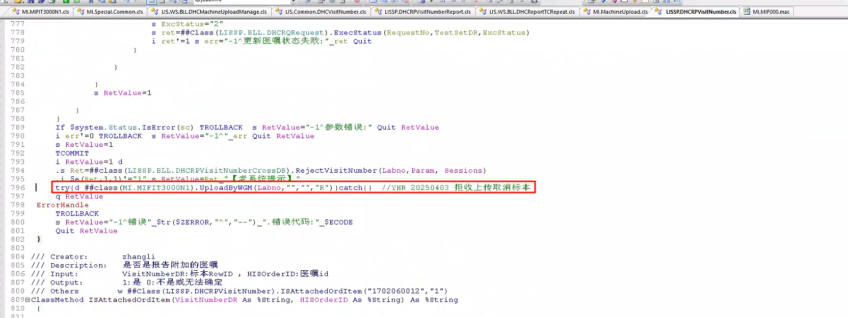​

审核和复审时调用方法位置 LISSP.DHCRPVisitNumberReport--SaveResult

​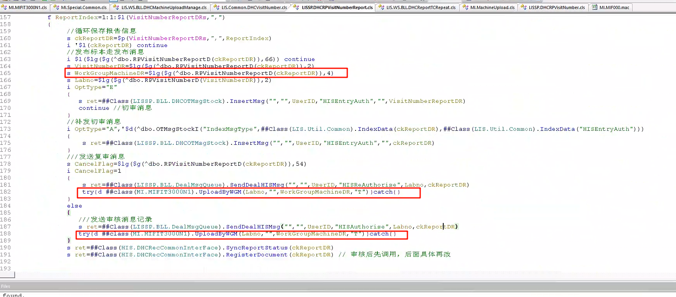​

/// 按小组重置上传列表  
/// d ##class(MI.MIFIT3000N1).UploadByWGM("8000000413","","41","R")  
/// d ##class(MI.MIFIT3000N1).UploadByWGM("8000000413","",41,"T")  
/// d ##class(MI.MIFIT3000N1).UploadByWGM("8000000413","",41,"U")  
ClassMethod UploadByWGM(Labno, TestSetDR, WorkGroupMachineDR, SendStatus) As %String  
{  
 s Labno=$g(Labno),TestSetDR=$g(TestSetDR),WorkGroupMachineDR=$g(WorkGroupMachineDR)  
 i '$l(Labno) q 100  
 i '$l(TestSetDR),'$l(WorkGroupMachineDR),SendStatus'="R" q 100   
  
 i SendStatus="R",'$d(^dbo.RPMachineUploadI("IndexVisitNumber",Labno)) q  
 i SendStatus="R" {  
 s MachineDR="" f s MachineDR=$o(^dbo.RPMachineUploadI("IndexVisitNumber",Labno,MachineDR)) q:MachineDR="" d  
 .s UploadDR="" f s UploadDR=$o(^dbo.RPMachineUploadI("IndexVisitNumber",Labno,MachineDR,UploadDR)) q:UploadDR="" d  
 ..S obj=##class(dbo.RPMachineUpload).%OpenId(UploadDR)  
 ..s obj.MachineParameterDR=MachineDR  
 ..s obj.VisitNumber=Labno  
 ..s obj.SendStatus=SendStatus  
 ..s obj.AddDate=$tr($zd(+$h,3),"-")  
 ..s obj.AddTime=$p($h,",",2)  
 ..s obj.TCList="END"  
 ..s ret=obj.%Save()  
 }else{  
 s ReplaceWGMDRData="3,41"  
 s QuitFlag=0  
 for i=1:1:$l(ReplaceWGMDRData,",") q:QuitFlag="1" d  
 .i WorkGroupMachineDR=$p(ReplaceWGMDRData,",",i) d  
 ..s WorkGroupMachineDR="96"  
 ..s QuitFlag=1  
  
 i SendStatus="T" {  
 s ReplaceWGMDRData="1,3,41" //屏蔽所有，这里维护所有可以上传的工作小组  
 s WorkGroupMachineDRBAK=WorkGroupMachineDR  
 s WorkGroupMachineDR=""  
 s QuitFlag=0  
 for i=1:1:$l(ReplaceWGMDRData,",") q:QuitFlag="1" d  
 .i WorkGroupMachineDRBAK=$p(ReplaceWGMDRData,",",i) d  
 ..s WorkGroupMachineDR="96"  
 ..s QuitFlag=1  
 s WorkGroupMachineDR="96" //所有的审核都发送归档标志  
 }  
 s SendStatus=$g(SendStatus)  
 s VisitNumberDR=$o(^dbo.RPVisitNumberI("IndexVisitNumber",##Class(LIS.Util.Common).IndexData(Labno),""))  
 I $L(WorkGroupMachineDR) d  
 .D UploadTC   
 }  
 q "1"  
UploadTC  
 s CommDirection=$lg(^dbo.BTWorkGroupMachineD(WorkGroupMachineDR),11)  
 i CommDirection'="UP",CommDirection'="LS" q 100  
 s ret=100  
 s MachineDR=""   
 f s MachineDR=$o(^dbo.BTMIMachineParameterI("IndexWorkGroupMachine",WorkGroupMachineDR,MachineDR)) q:MachineDR="" d  
 .s miCommDirection=$lg(^dbo.BTMIMachineParameterD(MachineDR),11)  
 .i miCommDirection'="UP",miCommDirection'="LS" q   
 .d ScanOneON^MI.MIF000(MachineDR,Labno)  
 .s TCList=""  
 .s chl="" f s chl=$o(^TMP("MIFTESTCODE",$j,MachineDR,Labno,chl)) q:chl="" d  
 ..s TCList=TCList_chl_"\"  
 .s TCList=$e(TCList,1,$l(TCList)-1)  
 .i '$l(TCList),SendStatus'="T" s ret=Labno_"没有上传项目" q  
  
 .s RowID=""  
 .i $d(^dbo.RPMachineUploadI("IndexMaster",MachineDR,##Class(LIS.Util.Common).IndexData(Labno))) S RowID=$O(^dbo.RPMachineUploadI("IndexMaster",MachineDR,##Class(LIS.Util.Common).IndexData(Labno),"")) //q  
 .I $L(RowID) S obj=##class(dbo.RPMachineUpload).%OpenId(RowID)  
 .E s obj=##class(dbo.RPMachineUpload).%New()  
 .//i $L(obj.SendStatus),obj.SendStatus'="C" Q //已读取标本不再上传  
 .s obj.MachineParameterDR=MachineDR  
 .s obj.VisitNumber=Labno  
 .s obj.SendStatus="C"  
 .i $l(SendStatus) s obj.SendStatus=SendStatus  
 .s obj.AddDate=$tr($zd(+$h,3),"-")  
 .s obj.AddTime=$p($h,",",2)  
 .i SendStatus="T" s TCList="DM_OVER"  
 .s obj.TCList=TCList  
 .s ret=obj.%Save()  
 q 0  
}

#### 标本上传处理修改显示

由于仪器和实际工作的工作小组不在一个位置，造成如果为上传成功时，重新上传查询不到标本，修改页面查询query逻辑 "LIS.WS.BLL.DHCMachineUploadManage","QrySampleStatus",

​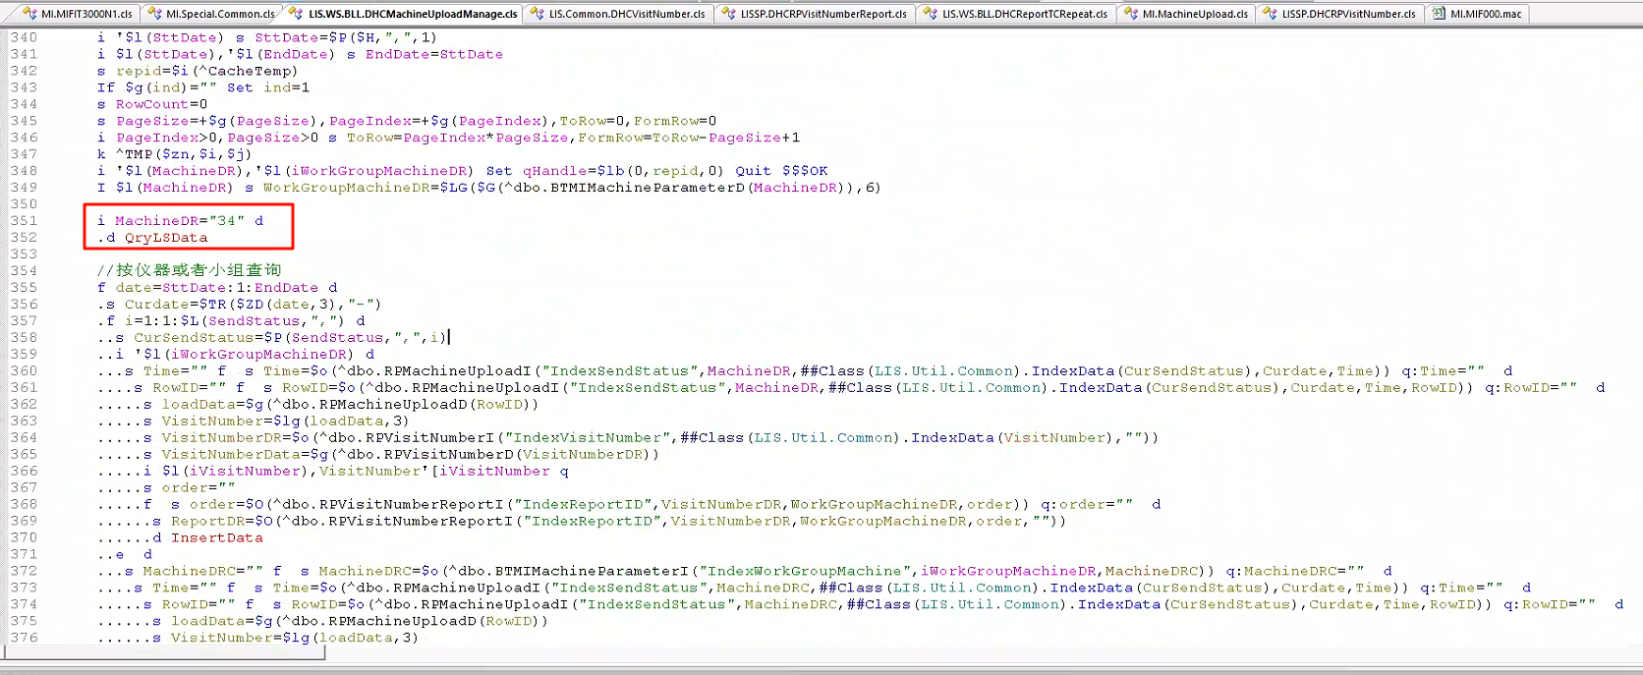​

​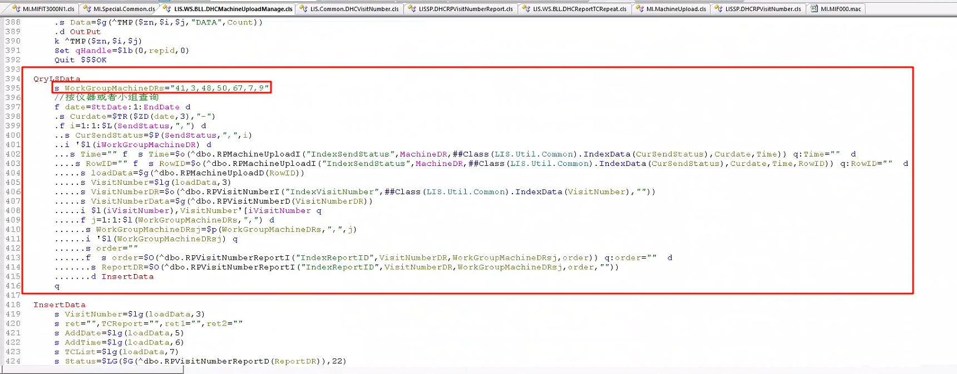​

​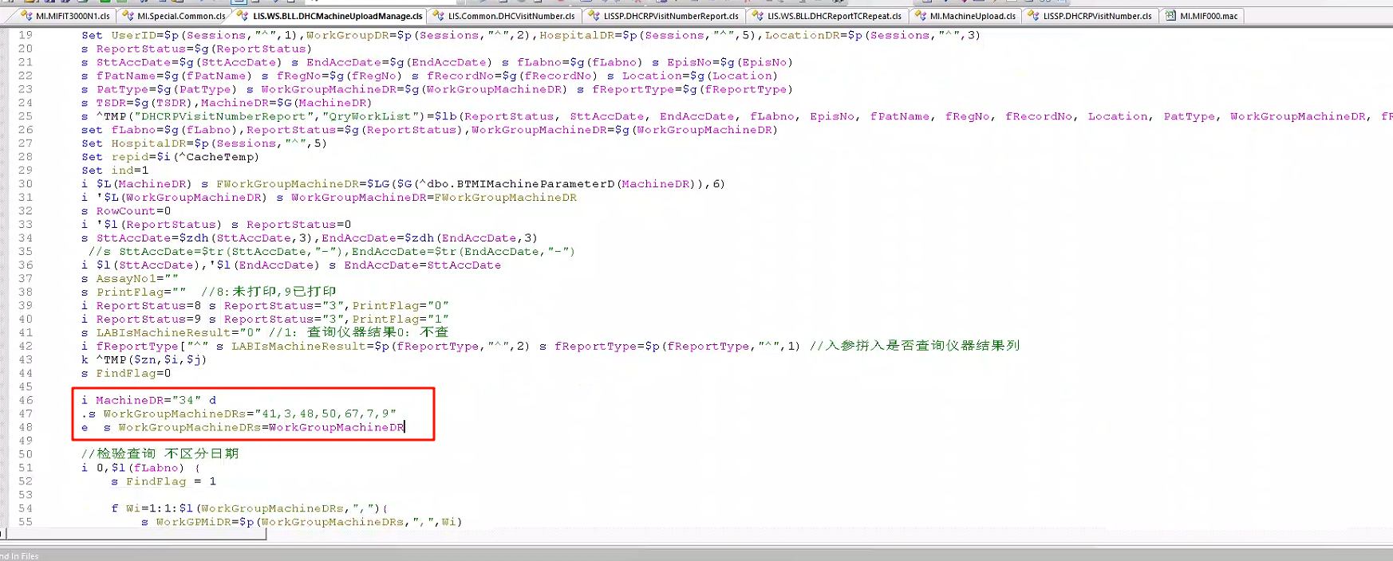​

i MachineDR="34" d  
 .s WorkGroupMachineDRs="41,3,48,50,67,7,9"  
 e s WorkGroupMachineDRs=WorkGroupMachineDR

QryLSData  
 s WorkGroupMachineDRs="41,3,48,50,67,7,9"  
 //按仪器或者小组查询  
 f date=SttDate:1:EndDate d  
 .s Curdate=$TR($ZD(date,3),"-")  
 .f i=1:1:$L(SendStatus,",") d  
 ..s CurSendStatus=$P(SendStatus,",",i)  
 ..i '$l(iWorkGroupMachineDR) d  
 ...s Time="" f s Time=$o(^dbo.RPMachineUploadI("IndexSendStatus",MachineDR,##Class(LIS.Util.Common).IndexData(CurSendStatus),Curdate,Time)) q:Time="" d  
 ....s RowID="" f s RowID=$o(^dbo.RPMachineUploadI("IndexSendStatus",MachineDR,##Class(LIS.Util.Common).IndexData(CurSendStatus),Curdate,Time,RowID)) q:RowID="" d  
 .....s loadData=$g(^dbo.RPMachineUploadD(RowID))  
 .....s VisitNumber=$lg(loadData,3)  
 .....s VisitNumberDR=$o(^dbo.RPVisitNumberI("IndexVisitNumber",##Class(LIS.Util.Common).IndexData(VisitNumber),""))  
 .....s VisitNumberData=$g(^dbo.RPVisitNumberD(VisitNumberDR))  
 .....i $l(iVisitNumber),VisitNumber'[iVisitNumber q  
 .....f j=1:1:$l(WorkGroupMachineDRs,",") d  
 ......s WorkGroupMachineDRsj=$p(WorkGroupMachineDRs,",",j)  
 ......i '$l(WorkGroupMachineDRsj) q  
 ......s order=""  
 ......f s order=$O(^dbo.RPVisitNumberReportI("IndexReportID",VisitNumberDR,WorkGroupMachineDRsj,order)) q:order="" d  
 .......s ReportDR=$O(^dbo.RPVisitNumberReportI("IndexReportID",VisitNumberDR,WorkGroupMachineDRsj,order,""))  
 .......d InsertData  
 q

## 问题处理记录

本节点为接口使用过程中踩过的雷和遇到过的问题以及处理方案

### 无法及时读取文件处理造成获取结果过慢

1.修改监听配置，允许同一台电脑上存在多个监听。（新版本监听支持，本接口对应使用软件在附件中）

监听中存在两个配置，**AllowMultiOpen（是否允许多开，1允许，0不允许，默认不允许）**和**OpenMessageService（多开版本维护为0，如果是1的话会造成系统崩溃！！！如果是正常在用电脑，其中一个维护为1就可以，其他的一定要设置为0）**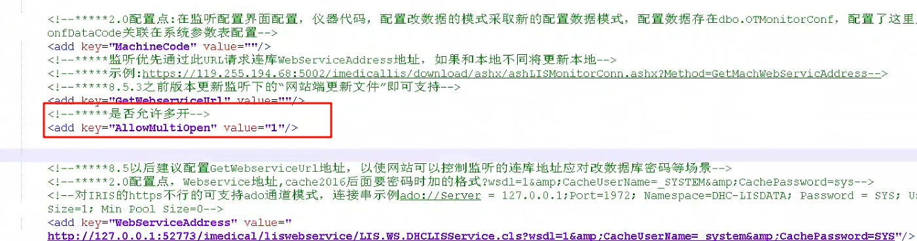​

​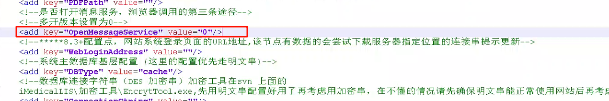​

在监听配置中，配置多个监听读取。本接口配置多个监听，主监听读取结果，额外配置两个，一个读取流水线处理文件，一个读取图片和上传信息（！！！这两个功能一定要在一起，上传参数 **"UPPreDealClass":"PreDeal.DealDemoM,PreDeal"**配置后，就一定会主动上传文件，所以一定一定一定再一起！！！）

2.使用job线程处理。监听固定调用对应接口的fileMTHD方法，读取结果与系统其他方法没有交互，因此将具体的处理方法另外写了方法 **ResultDo** ，通过文件名包含路径进行判断，如果是结果RESULT文件，用job调用存储结果，如果是处理SEEN文件，用do调用处理结果。加快解析读取结果速度。

### 仪器未获取到项目问题

1.读取结果不能及时时，进行了监听配置配置多个监听，最开始是为了分工明确，设置了四个监听，一个用来读取结果RESULT，一个用来读取处理文件SEEN，一个用来上传信息，一个用来读取图片。读取图片的配置和上传信息的配置处理类是同一个，读取图片多了一个额外的读取图片路径。

最开始认为，读取图片的配置，不配置上传信息的路径，就不会进行上传。后面科室经常说会有漏标本漏项目的情况，经过多次排查核对日志后，发现被读取图片配置的监听上传了文件，因为没有配置上传路径，将上传的文件存在了监听对应的根路径。后面修改为上传信息和读取图片合为一个监听，最终为三个监听，一个读取结果，一个读取处理文件，一个上传信息+读取图片。

2.修改后仍旧有漏项目的情况，确定仪器电脑只有三个监听，三个监听的日志都有认真排查。后面使用获取调用webservice的ip方法 w ##Class(LIS.Util.Common).GetClientIP()​，查询到有其他电脑配置了监听，造成被其他电脑抢走了。

3.上传过快造成未接收完标本已经上传，造成漏项目问题，判断接收5s内不上传。遇到偶发问题，上传时间与接收时间为0甚至上传时间比接收时间早1s，判断是事务未完成已经发送。设置上传时间大于-2秒不上传。

### 报警信息过长保存到其他结果字段时造成无法保存仪器结果

报警信息存放在结果说明字段，会将结果说明字段发送给临床医生，很多医院要求报警信息不发送给临床医生，因此将报警信息存放至其他结果字段。然而其他结果字段，在dbo.RPMachineResult​仪器结果表和dbo.RPMachineResultLog​仪器结果日志表中字段OtherRes​设置长度较短，就会造成存储时报错但是前台没有任何提示。扩长后可以正常的对应到结果。

如果仪器维护报警结果不传输，如果没有结果，其他结果也不会赋值，因此要根据实际进行判断，如果有报警信息但是没有结果，设置结果为ERR，报警信息就可以正常的保存显示。

### 同时存在大量标本，查询速度过慢，造成堆积无法正常上传项目

批量手工登记，造成同时存在超多标本等待上传，由于主动上传查询query中，包含申请项目上传，复查项目上传，回退项目上传和审核项目上传，造成查询速度过慢

监听查询等待时间为60s，如果超过时间认为查询超时，就不再等待进行上传，会提示查询错误超过50次。因此对于接口进行处理，申请项目上传分批上传，超过10个就停止查询直接输出。

‍